Mitesh Rathod

Kimberley College

NEA PROJECT REPORT

Movie search and recommender system

MOODVIE

**Analysis**

**The Problem**

There are many streaming services available presently with a wide variety of movies, TV shows and documentaries (e.g. Netflix and Amazon Prime). Many of these streaming services have their own recommendation systems which provide recommendations based on user viewing history and

However, there is a need for a web application which can recommend movies based on the mood of the viewer in addition to the interests and viewing history. While, services such as Netflix may have their own recommendation systems, they are only limited to the movies that are currently viewable on the service. These systems do not encompass a wider database of movies which the user can view. There also are many users who can experience confusion and indecision over which movies to watch. A web application which narrows this search down even further, basing the recommendation on the user’s current mood with other important factors such as age, gender and geographic location.

**Third Party Interview:**

A third-party interview was conducted in order to understand the needs of a typical user which would give an insight into their problems with current systems in streaming services.

**Interview with R. Rathod – A typical end-user**

**What streaming services do you use and what do you usually watch?**

**Ans:** I usually use Netflix, Amazon Prime, Now TV and Disney Plus. I mainly watch movies and TV Shows.

**How do you normally decide what to watch?**

**Ans:** I usually find something to watch using the help of the recommendations and my own watch later list.

**How would you rate the recommendation system on Netflix?**

**Ans:** The recommendations are good as they show titles which are related to genres that I like however one flaw Is that sometimes I would like to watch movies which may not be available on Netflix which occurs in all the streaming services I am currently using.

**Further Research**

There are many ways of creating recommendation systems, but one of the most popular ones, wildly used in real world applications is collaborative filtering.

**Collaborative filtering:**

Collaborative filtering is one approach to the design of recommendation systems. Collaborative flittering is based on the assumption that if a person agrees in the past, they will agree in the future which may be a limitation. It also compares other users with similar liked history allowing to recommend more accurate recommendations and for the user to explore different things they may also like. There are two ways to collect data; explicit and implicit data collection.

Examples of explicit data collection:

* Asking the user to create a list of things he/she likes (Rocchio classification is something that may be used with this)
* Ask the user to search for items.
* Asking the user to rate an item whether that be a sliding line or a rate from 1-10
* Asking the user to rank a list of items from best to worst or favourite to least favourite.

Examples of implicit data collection:

* Keeping records of what the user buys/watches.
* Analysing item/user viewing times
* Analysing the user’s social network and discovering similar likes and dislikes.

Many issues may occur when using collaborative filtering system however there are three issues that occur the most often. Cold start, scalability, and sparsity.

* Cold Start: This is when a new user hasn’t given enough data to generate accurate recommendations.
* Scalability: This is when the amount of data given is too big to compute and will take a lot of time and computing power to work.
* Sparsity: The number of items sold on major e-commerce sites is extremely large. The most active users will only have rated small subset of overall database. Thus, even the most popular items on shopping websites like Amazon.com have very few ratings.

Observations of Existing Systems:

https://www.youtube.com/watch?v=mEOLjW4YuOE

Link to see a demo of the existing system

**Objectives**

1. To have a full personalised user experience where recommendations of movies are made using user’s data (e.g. preferences).
2. Algorithms used to determine movie recommendations.
3. User accounts, including a login page.
4. SQL databases with user details.
5. Use of APIs from online movie databases (e.g. TMDB (the movie database).
6. Users can also use film search feature.

**Extension Objectives:**

1. Neural networks
2. Looking at complex recommendation systems used in real world application such as SVD and SVD++.
3. K-nearest neighbour(k-NN)
4. Cosine similarity(Machine Learning)

**How will the objectives be met?:**

**Objective 1:**

This objective is met with the help of a combination of things such as a database. Whenever a user creates an account, an entry with their username, passwords and unique identifier is stored. The unique identifier is used to identify which movies are stored in the users watch later list. Recommendations are then made using the list of movies we know the user likes already.

**Objective 2:**

This objective will be met using cosine similarity which is a form of machine learning and also one of my extension objectives. The movies in the user’s watch later list will be used to generate recommendations. The data from the movies used include key words, genre and director of the movies as other movies with similar data within theses categories tend to be quite similar and most also liked by our user.

**Objective 3:**

This objective will be met using flask login, flask and html. Flask is a web framework which allows for webpages to be created with the help of python. A page made for signing is created in html, hosted on flask, the data entered into the field on the page will be passed into the python files, so the data can be saved or manipulated for example the hashing of passwords using a library.

**Objective 4:**

The objective will be met using SQL Alchemy. Once the details of the sign up are retrieved they are passed into the SQL database.

**Objective 5:**

The objective will be met with the help of the TMDB API, which provides details of movies, TV shows, actors, directors etc. This data can then be used to create the website.

**Objective 6:**

The search function is built into the API, however the HTML would need to be coded. As the user types the search query into the search bar it is then passed into the python code which can then use to API to complete the query. The data is then passed back from the API Into the python code, this data is then passed forward to another HTML. The HTML then uses jinja to get the specific data needed to be displayed.

**Documented Design**

**Hierarchy chart of the website**

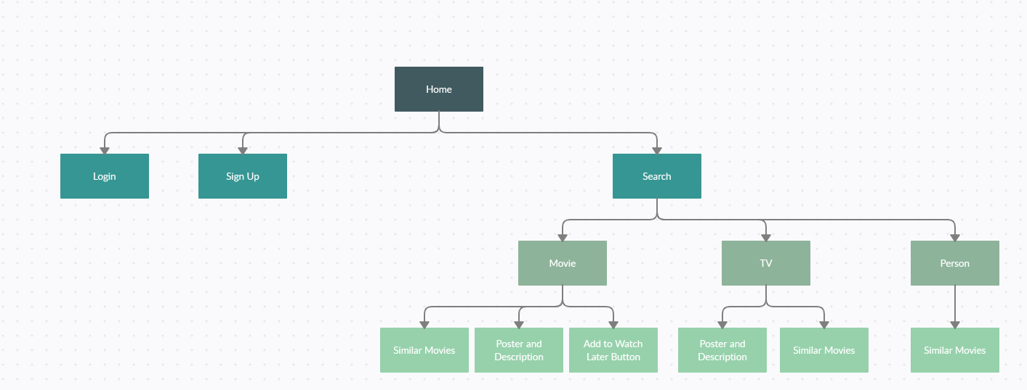

**Entity relationship diagram**

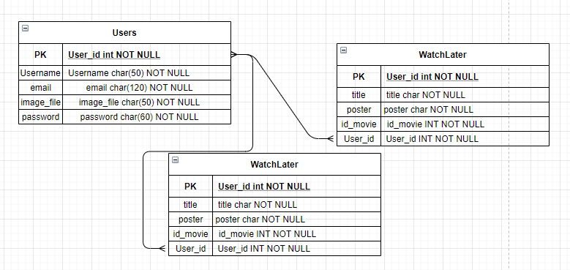Many to many relationships as many users can have many films under their name

**File structure**

C:.

│ demo.txt

│ movie_dataset.csv

│ README.txt.txt

│ run.py

│

├───.idea

│ │ .gitignore

│ │ Flask stuff.iml

│ │ misc.xml

│ │ modules.xml

│ │ vcs.xml

│ │ workspace.xml

│ │

│ └───inspectionProfiles

│ profiles_settings.xml

│

├───Flask2

│ │ demo.txt

│ │ forms.py

│ │ models.py

│ │ movie_dataset.csv

│ │ routes.py

│ │ RUN.py

│ │ site.db

│ │ testing123.csv

│ │ try.py

│ │ __init__.py

│ │

│ ├───static

│ │ main.css

│ │

│ ├───templates

│ │ error.html

│ │ Film.html

│ │ film1.html

│ │ index.html

│ │ layout.html

│ │ login.html

│ │ Moodvie.png

│ │ movie.html

│ │ Multi.html

│ │ new.html

│ │ new1.html

│ │ Person.html

│ │ Rec.html

│ │ register.html

│ │ try.html

│ │ TV.html

│ │ Watchlater.html

│ │ watchlater.png

│ │

│ └───__pycache__

│ forms.cpython-37.pyc

│ models.cpython-37.pyc

│ routes.cpython-37.pyc

│ __init__.cpython-37.pyc

│

└───__pycache__

forms.cpython-37.pyc

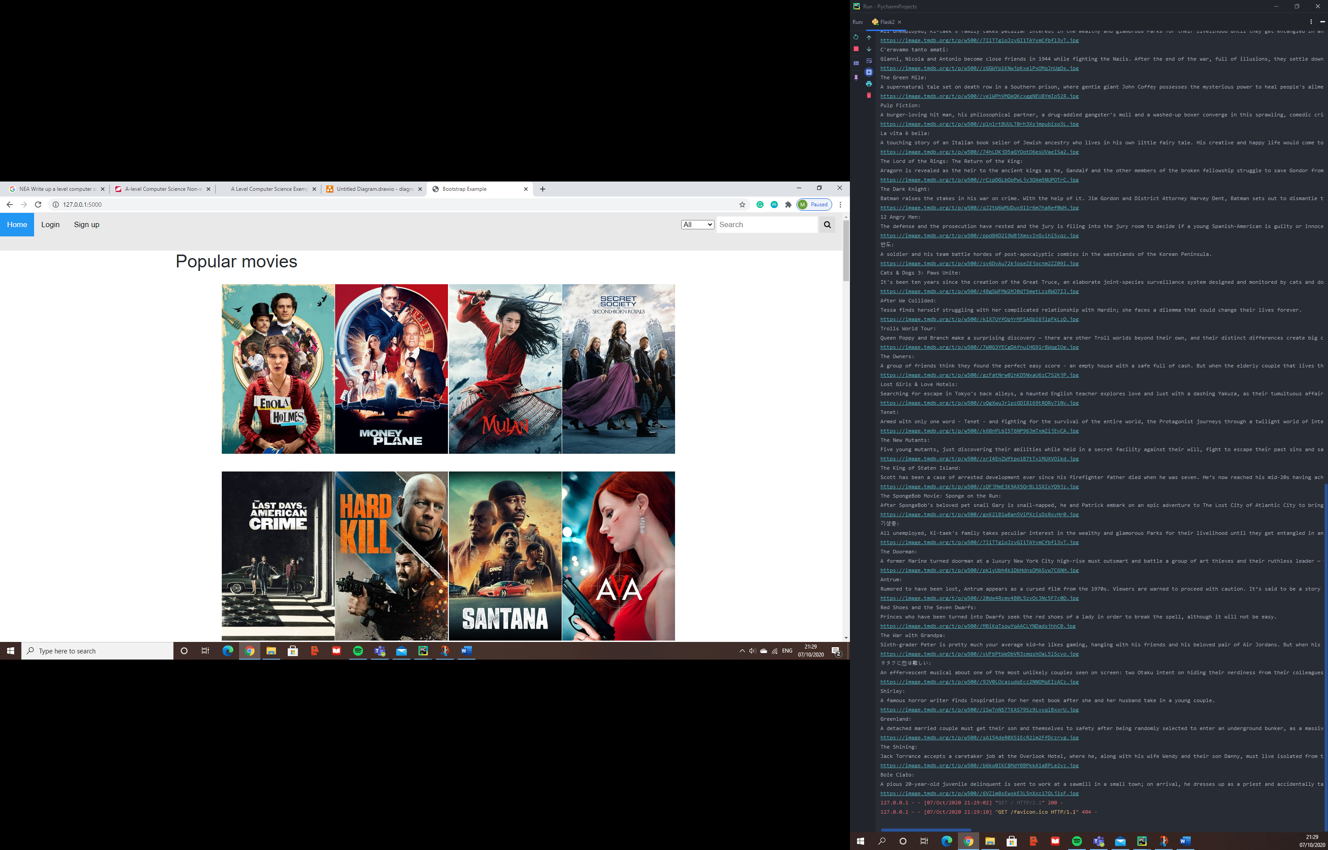

This is a drop own where options can be chosen from the different categories.

The images are buttons which lead to each Film’s individuals pages.

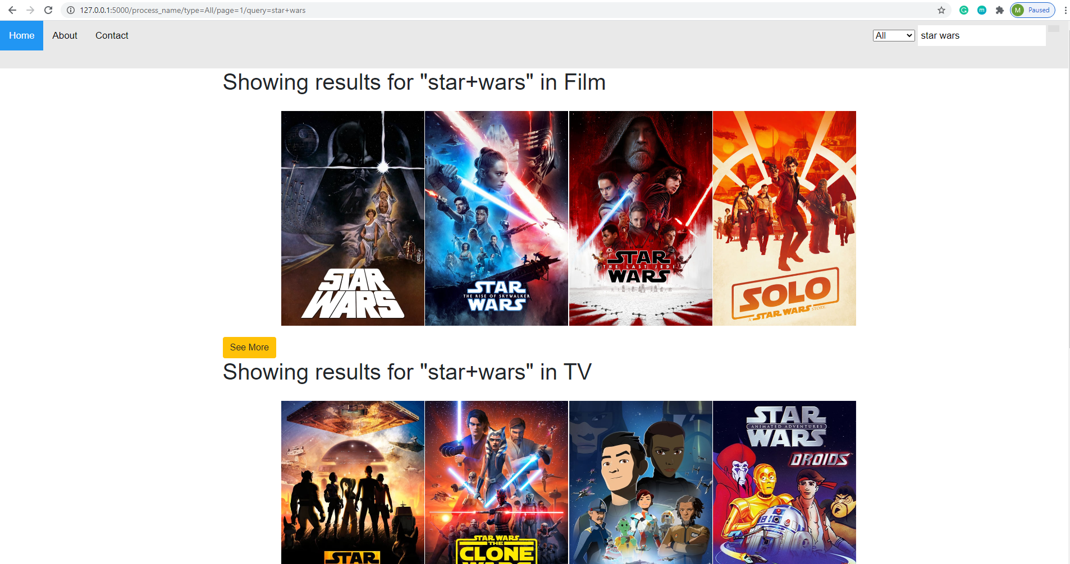

See more links lead to pages with, more results either in the Films, TV or even people

Smart link which can be used to search as well as all that needs to be passed in is the type, page and the query.

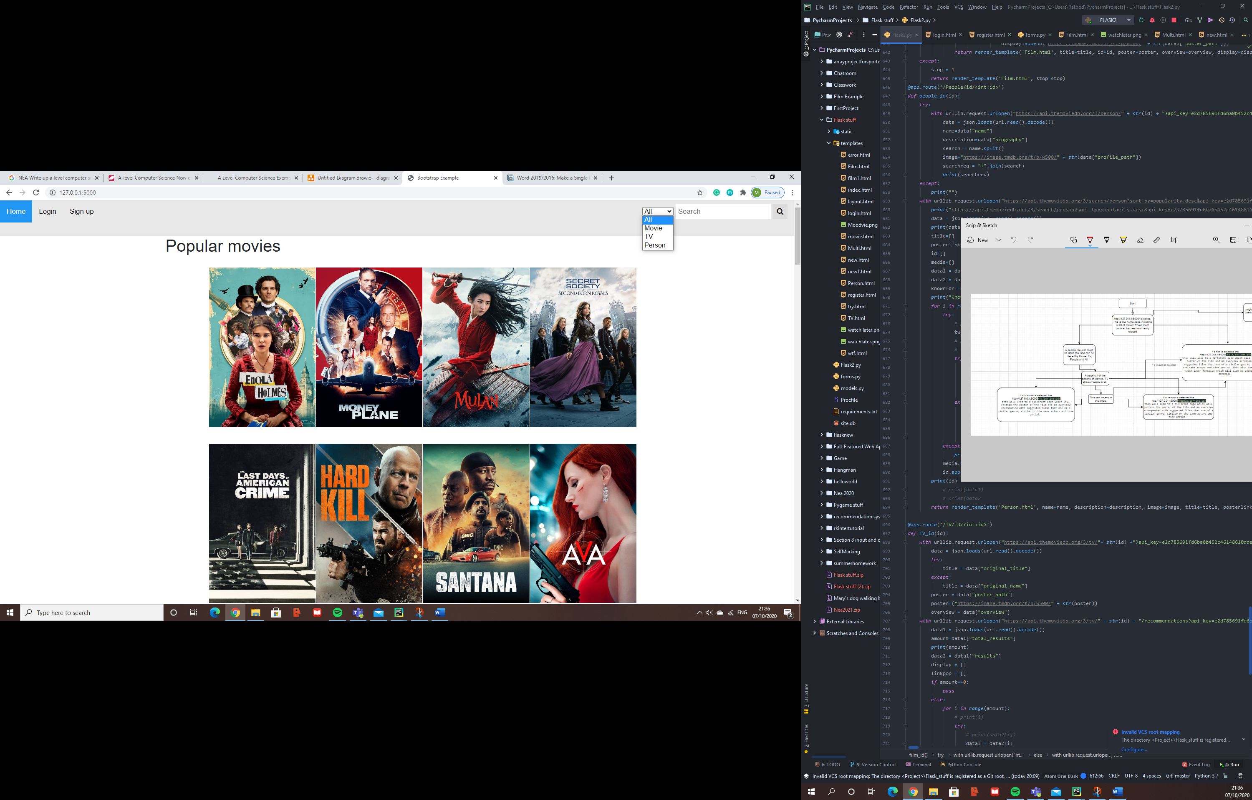

My project now includes other things such as an All function along with a TV and Person option rather than the older version of the project which just focused on Movies.

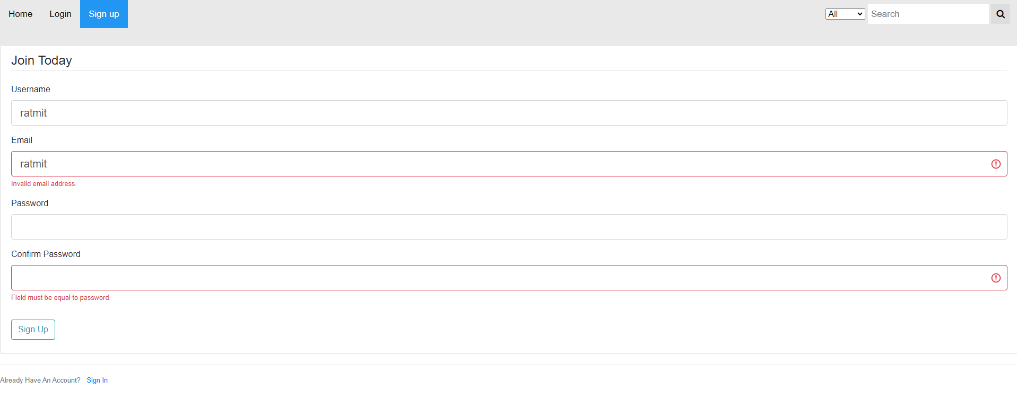Checks are taken place so that the details that are entered are valid so they can be submitted to the database.



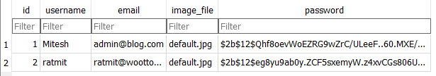Once all checks have taken place the account is then added to the database

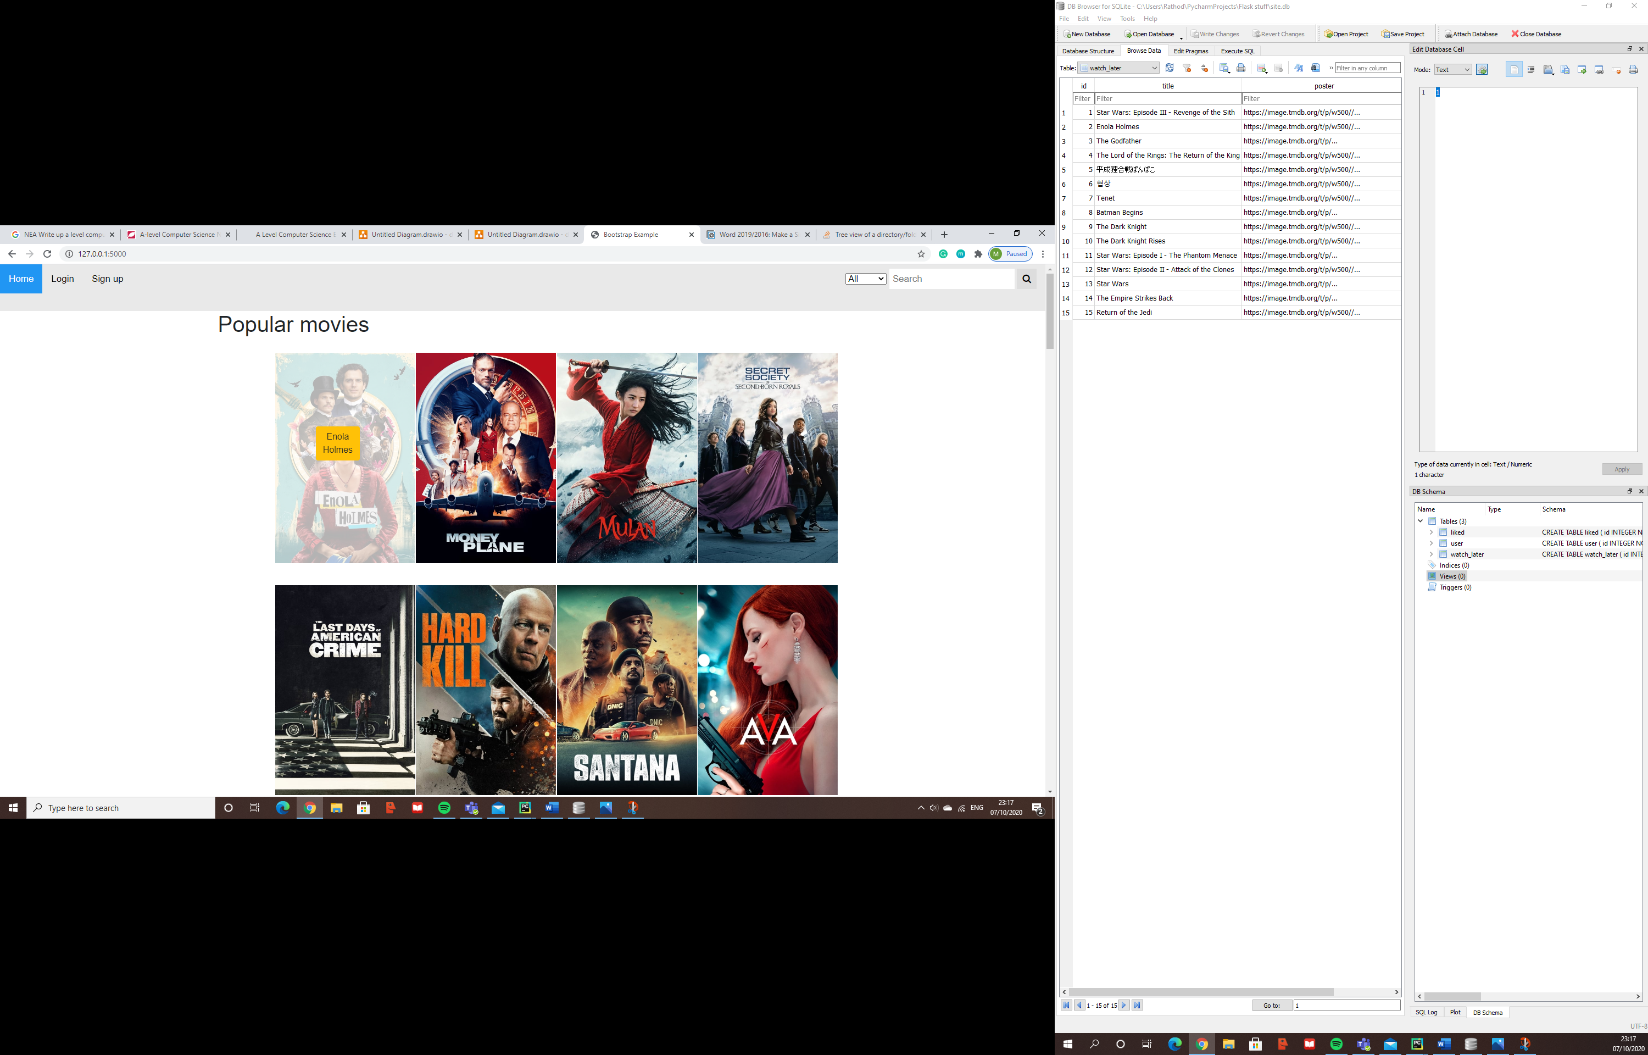The passwords are also hashed to increase security. So that if the database is leaked the details of the users will not be compromised as they would not be able to decode the hashed password without having to go through a considerable amount of effort to do so.

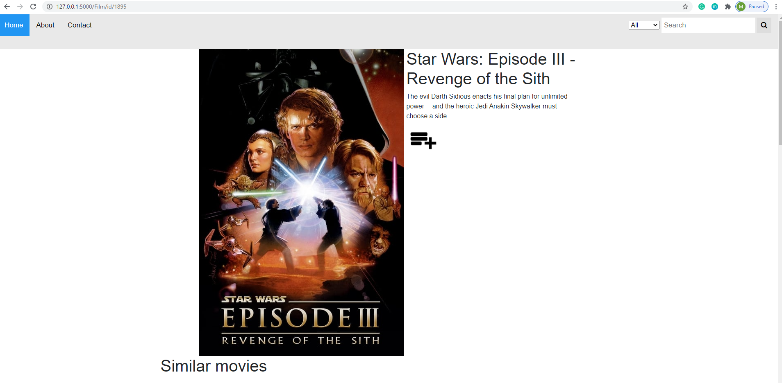

Watch later button adding this to the watch later table in the database.

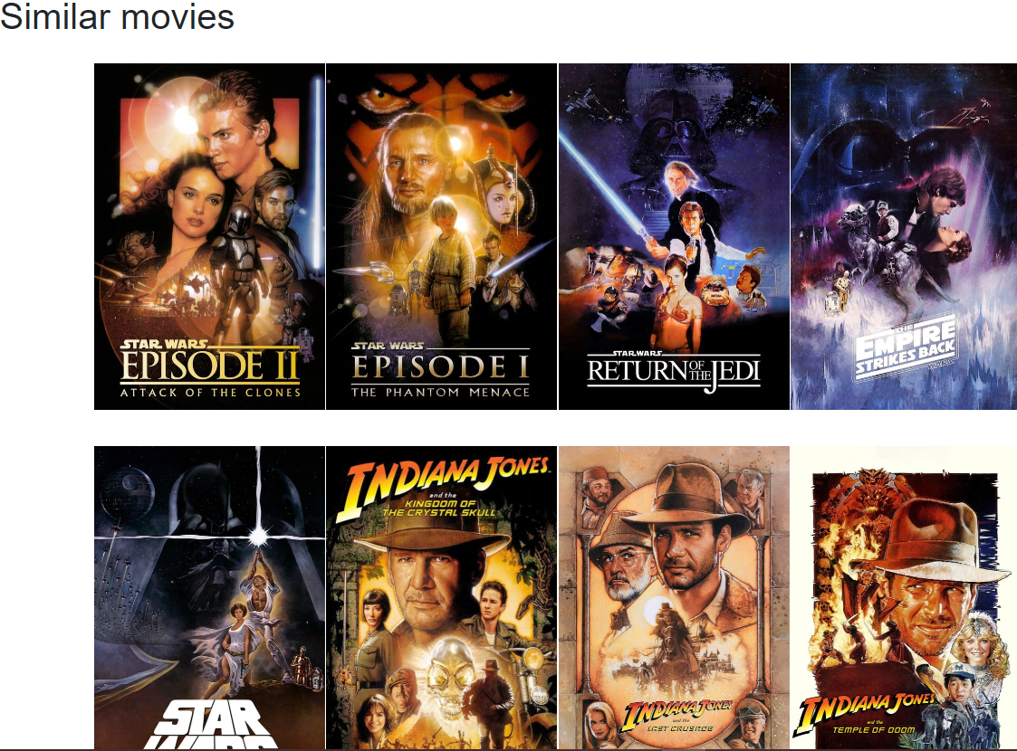**Similar films**

**Implementation**

This Project consist of a range of languages including Python and HTML.

**Section 1**

Section 1 focuses on the key algorithms in Python

**Section 1.1**

**RUN.py**

|  |  |
| --- | --- |
| **Algorithm:** Add movie to movie recommendation database. | **Location:** RUN.py line 15 to line 53 |
| **Description:** | |
| The algorithm gets all the new movies that have been added to all the users databases and added to a movie recommender database so that a recommendation can be created based upon the movie and its attributes. It retrieves the data of the film using the TMDB API. | |
| **Code:** | |
| *def* add_movie(id, title):  f = *open*("C:/Users\Rathod\PycharmProjects\Flask stuff\Flask2\demo.txt", "r")  abc = f.read()  *with* urllib.request.urlopen("https://api.themoviedb.org/3/movie/" + *str*(  id) + "?api_key=e2d785691fd6ba0b452c46148610dde4&language=en-US") *as* url:  data = json.loads(url.read().decode())  a = *len*(data["genres"])  b = data["genres"]  _string = ""  *for* i *in range*(a):  _string = _string + b[i]["name"] + " "  *with* urllib.request.urlopen("https://api.themoviedb.org/3/movie/" + *str*(  id) + "/keywords?api_key=e2d785691fd6ba0b452c46148610dde4") *as* url:  data = json.loads(url.read().decode())  c = (data["keywords"])  _len = *len*(data["keywords"])  _string2 = ""  *for* i *in range*(_len):  _string2 = _string2 + c[i]["name"] + " "  *with* urllib.request.urlopen("https://api.themoviedb.org/3/movie/" + *str*(  id) + "/credits?api_key=e2d785691fd6ba0b452c46148610dde4&language=en-US") *as* url:  data = json.loads(url.read().decode())  _len1 = *len*(data["crew"])  director = ""  *for* i *in range*(_len1):  *if* data["crew"][i]["known_for_department"] == "Directing":  director = director + data["crew"][i]["name"]  *break  with open*('movie_dataset.csv', 'a', encoding="utf-8") *as* csvfile:  fieldnames = [*str*(abc), "", *str*(_string), "", *str*(id), *str*(_string2), "", *str*(title), "", "", "", "", "", "",  "", "", "", "", *str*(title), "", "", "", "", *str*(director)]  *print*(fieldnames)  writer = csv.writer(csvfile)  writer.writerow(fieldnames)  df = pd.read_csv("""C:/Users\Rathod\PycharmProjects\Flask stuff\Flask2\movie_dataset.csv""")  b = *int*(abc) + 1  f = *open*("demo.txt", "w")  f.write(*str*(b))  f.close() | |

**Section 1.2**

**Routes.py**

|  |  |
| --- | --- |
| Algorithm: Gather data for main page of website. | Location: routes.py line 17 to line 79. |
| Description | |
| This is the code for the main page of the website, it collects data from API’s along with finding the current user. All the data is packaged up and passed to the html file in a way in which it can iterate and display the correct data in the right places. | |
| Code | |
| @app.route('/') *def* index():  *print*("BDKHBDKSKJBSKJBSKJBSKJB KJHKSJHKSJHKJSH KJHKJH KJHKASJHKJ HKjhkdjhf ksdj fhksjdhf kjshdfkhKSJHFDKSJDHFKSJ DKFJSKDF KSDJF SKDJF SKDJF SKDJF SKDJF HSDKJF SDKFJSDKFJSDKFJSD HFKSJDFSKDJF SKDJFSKDJF HSKDJFHSKDJFSKDJF SKDJFKSJDF ")  *print*(current_user)  *print*("BDKHBDKSKJBSKJBSKJBSKJB KJHKSJHKSJHKJSH KJHKJH KJHKASJHKJ HKjhkdjhf ksdj fhksjdhf kjshdfkhKSJHFDKSJDHFKSJ DKFJSKDF KSDJF SKDJF SKDJF SKDJF SKDJF HSDKJF SDKFJSDKFJSDKFJSD HFKSJDFSKDJF SKDJFSKDJF HSKDJFHSKDJFSKDJF SKDJFKSJDF ")  *#This is when i will retirive the data from the api, this specific query will be popular movies which are selected by tmdb  with* urllib.request.urlopen("https://api.themoviedb.org/3/movie/popular?api_key=e2d785691fd6ba0b452c46148610dde4&language=en-US&page=1") *as* url:  data1 = json.loads(url.read().decode())  data2 = data1["results"]  *#these variables will store the info needed to be displayed and passed to the html file* popmov=[]  linkpop=[]  *for* i *in range*(20):  *# print(i)  try*:  *# print(data2[i])* data3 = data2[i]  *except*:  *continue  try*:  *print*(data3["original_name"] + ":")  *if* "/n" *in* data3["original_name"]:  strippedtitle=data3["original_name"].replace("/n", " ")  popmov.append(strippedtitle)  *else*:  popmov.append(data3["original_name"])  *except*:  *print*(data3["original_title"] + ":")  *if* "/n" *in* data3["original_title"]:  strippedtitle=data3["original_title"].replace("/n", " ")  popmov.append(strippedtitle)  *else*:  popmov.append(data3["original_title"])  linkpop.append(data3["id"])  *print*(data3["overview"])  *print*("https://image.tmdb.org/t/p/w500/" + *str*(data3["poster_path"]))  popmov.append("https://image.tmdb.org/t/p/w500/" + *str*(data3["poster_path"]))   *with* urllib.request.urlopen("https://api.themoviedb.org/3/movie/top_rated?api_key=e2d785691fd6ba0b452c46148610dde4&language=en-US&page=1") *as* url:  data1 = json.loads(url.read().decode())  data2 = data1["results"]  topmov=[]  linkpop1 = []  *for* i *in range*(20):  *# print(i)  try*:  *# print(data2[i])* data3 = data2[i]  *except*:  *continue  try*:  *print*(data3["original_name"] + ":")  topmov.append(data3["original_name"])  *except*:  *print*(data3["original_title"] + ":")  topmov.append(data3["original_title"])  linkpop1.append(data3["id"])  *print*(data3["overview"])  *print*("https://image.tmdb.org/t/p/w500/" + *str*(data3["poster_path"]))  topmov.append("https://image.tmdb.org/t/p/w500/" + *str*(data3["poster_path"]))   *with* urllib.request.urlopen("https://api.themoviedb.org/3/movie/upcoming?api_key=e2d785691fd6ba0b452c46148610dde4&language=en-US&page=1") *as* url:  data1 = json.loads(url.read().decode())  data2 = data1["results"]  upmov=[]  linkpop2 = []  *for* i *in range*(20):  *# print(i)  try*:  *# print(data2[i])* data3 = data2[i]  *except*:  *continue  try*:  *print*(data3["original_name"] + ":")  upmov.append(data3["original_name"])  *except*:  *print*(data3["original_title"] + ":")  upmov.append(data3["original_title"])  linkpop2.append(data3["id"])  *print*(data3["overview"])  *print*("https://image.tmdb.org/t/p/w500/" + *str*(data3["poster_path"]))  upmov.append("https://image.tmdb.org/t/p/w500/" + *str*(data3["poster_path"]))  *return* render_template('index.html', popmov=popmov, topmov=topmov, upmov=upmov,linkpop=linkpop, linkpop1=linkpop1, linkpop2=linkpop2) | |

**routes.py**

|  |  |
| --- | --- |
| Algorithm: Gather data for search queries. | Location: routes.py line 92 to line 280. |
| Description | |
| This is the code that deals with the searching end of the website in terms of the type of search such as whether you are searching for a movie or an actor. It interacts with the API to get data and is then represented in a html file. | |
| Code | |
| @app.route('/process_name/type=<type>/page=<num>/query=<name>', methods = ['POST','GET']) *def* process(num, type, name):  *global* data  *global* name1  *global* poster  *global* twd  *if* type == "Person":  *with* urllib.request.urlopen("https://api.themoviedb.org/3/search/person?sort_by=popularity.desc&api_key=e2d785691fd6ba0b452c46148610dde4&query=" + name + "&page=" + *str*(num) + "&sort_by=popularity.desc") *as* url:  *print*("https://api.themoviedb.org/3/search/person?sort_by=popularity.desc&api_key=e2d785691fd6ba0b452c46148610dde4&query=" + name + "&page=1" + "&sort_by=popularity.desc")  display=[]  data = json.loads(url.read().decode())  *print*(data)  title = []  posterlink = []  id = []  pages = data['total_pages']  *if* data['total_results']<20:  a=data['total_results']  *else*:  a=20  data1 = data['results']  *for* i *in range*(a):  data2 = data1[i]  id.append(data2['id'])  knownfor = data2['known_for']  *print*("Known for:")  *for* i *in range*(3):  *try*:  *# print(i)* twd = (knownfor[i])  *# print(str(i) + " " + str(twd))  # stuff=""  try*:  *# stuff += (twd['original_name'])* title.append(twd['original_name'])  *if* twd['poster_path'] == "None":  posterlink.append("https://i.ibb.co/1n24z5s/Moodvie.png")  *else*:  posterlink.append("https://image.tmdb.org/t/p/w500/" + *str*(twd['poster_path']))  *print*(twd['original_name'] + " " + "https://image.tmdb.org/t/p/w500/" + *str*(  twd['poster_path']))  *except*:  title.append(twd['original_title'])  *if* twd['poster_path'] == "None":  posterlink.append("https://i.ibb.co/1n24z5s/Moodvie.png")  *else*:  posterlink.append("https://image.tmdb.org/t/p/w500/" + *str*(twd['poster_path']))  *# stuff += (twd['original_title'])  print*(twd['original_title'] + " " + "https://image.tmdb.org/t/p/w500/" + *str*(  twd['poster_path']))  *except*:  *print*("")  *# print(data1)  # print(data2)  print*(data2['name'])  name1 = data2['name']  poster = "https://image.tmdb.org/t/p/w500/" + *str*(data2['profile_path'])  *print*("https://image.tmdb.org/t/p/w500/" + *str*(data2['profile_path']))  display.append(name1)  display.append("https://image.tmdb.org/t/p/w500/" + *str*(data2['profile_path']))  *print*(display)  *return* render_template('new.html', display=display, title=title, posterlink=posterlink, id=id, name=name, pages=pages, type=type, a=a)  *elif* type == "Movie":  display = []  id=[]  *with* urllib.request.urlopen("https://api.themoviedb.org/3/search/movie?sort_by=popularity.desc&&include_adult=false&api_key=e2d785691fd6ba0b452c46148610dde4&language=en-US&page=" + *str*(num) + "&query=" + name) *as* url:  data = json.loads(url.read().decode())  data1=data['results']  pages = data['total_pages']  *if* data['total_results']<20:  a=data['total_results']  *else*:  a=20  *for* i *in range*(a):  *try*:  *# print(data2[i])* data3 = data1[i]  *except*:  *continue  try*:  display.append(data3["original_name"] + ":")  *except*:  display.append(data3["original_title"] + ":")  id.append(data3["id"])  display.append("https://image.tmdb.org/t/p/w500/" + *str*(data3["poster_path"]))  *return* render_template('new.html', display=display, id=id, type=type, pages=pages, name=name, a=a)  *elif* type == "TV":  display = []  id=[]  *with* urllib.request.urlopen("https://api.themoviedb.org/3/search/tv?sort_by=popularity.desc&api_key=e2d785691fd6ba0b452c46148610dde4&language=en-US&page=" + *str*(num) + "&include_adult=false&query=" + name) *as* url:  data = json.loads(url.read().decode())  data1=data['results']  pages = data['total_pages']  *if* data['total_results']<20:  a=data['total_results']  *else*:  a=20  *for* i *in range*(a):  *try*:  *# print(data2[i])* data3 = data1[i]  *except*:  *continue  try*:  display.append(data3["original_name"] + ":")  *except*:  display.append(data3["original_title"] + ":")  id.append(data3["id"])  display.append("https://image.tmdb.org/t/p/w500/" + *str*(data3["poster_path"]))  *return* render_template('new.html', display=display, id=id, type=type, pages=pages, name=name, a=a)  *elif* type == "All":  *with* urllib.request.urlopen("https://api.themoviedb.org/3/search/person?sort_by=popularity.desc&api_key=e2d785691fd6ba0b452c46148610dde4&query=" + name + "&page=" + *str*(num) + "&sort_by=popularity.desc") *as* url:  *print*("https://api.themoviedb.org/3/search/person?sort_by=popularity.desc&api_key=e2d785691fd6ba0b452c46148610dde4&query=" + name + "&page=1" + "&sort_by=popularity.desc")  display_person=[]  data = json.loads(url.read().decode())  *print*(data)  title = []  posterlink = []  id_person = []  pages = data['total_pages']  *if* data['total_results']<20:  a_P=data['total_results']  *else*:  a_P=20  data1 = data['results']  *for* i *in range*(a_P):  data2 = data1[i]  id_person.append(data2['id'])  knownfor = data2['known_for']  *print*("Known for:")  *for* i *in range*(3):  *try*:  *# print(i)* twd = (knownfor[i])  *# print(str(i) + " " + str(twd))  # stuff=""  try*:  *# stuff += (twd['original_name'])* title.append(twd['original_name'])  *if* twd['poster_path'] == "None":  posterlink.append("https://i.ibb.co/1n24z5s/Moodvie.png")  *else*:  posterlink.append("https://image.tmdb.org/t/p/w500/" + *str*(twd['poster_path']))  *print*(twd['original_name'] + " " + "https://image.tmdb.org/t/p/w500/" + *str*(  twd['poster_path']))  *except*:  title.append(twd['original_title'])  *if* twd['poster_path'] == "None":  posterlink.append("https://i.ibb.co/1n24z5s/Moodvie.png")  *else*:  posterlink.append("https://image.tmdb.org/t/p/w500/" + *str*(twd['poster_path']))  *# stuff += (twd['original_title'])  print*(twd['original_title'] + " " + "https://image.tmdb.org/t/p/w500/" + *str*(  twd['poster_path']))  *except*:  *print*("")  *# print(data1)  # print(data2  print*(data2['name'])  name1 = data2['name']  poster = "https://image.tmdb.org/t/p/w500/" + *str*(data2['profile_path'])  *print*("https://image.tmdb.org/t/p/w500/" + *str*(data2['profile_path']))  display_person.append(name1)  display_person.append("https://image.tmdb.org/t/p/w500/" + *str*(data2['profile_path']))  *print*(display_person)   display_TV = []  id_TV = []  *with* urllib.request.urlopen(  "https://api.themoviedb.org/3/search/tv?sort_by=popularity.desc&api_key=e2d785691fd6ba0b452c46148610dde4&language=en-US&page=" + *str*(  num) + "&include_adult=false&query=" + name) *as* url:  data = json.loads(url.read().decode())  data1 = data['results']  pages = data['total_pages']  *if* data['total_results'] < 20:  a_T = data['total_results']  *else*:  a_T = 20  *for* i *in range*(a_T):  *try*:  *# print(data2[i])* data3 = data1[i]  *except*:  *continue  try*:  display_TV.append(data3["original_name"] + ":")  *except*:  display_TV.append(data3["original_title"] + ":")  id_TV.append(data3["id"])  display_TV.append("https://image.tmdb.org/t/p/w500/" + *str*(data3["poster_path"]))  display_Movie = []  id_Movie = []  *with* urllib.request.urlopen("https://api.themoviedb.org/3/search/movie?sort_by=popularity.desc&&include_adult=false&api_key=e2d785691fd6ba0b452c46148610dde4&language=en-US&page=" + *str*(num) + "&query=" + name) *as* url:  data = json.loads(url.read().decode())  data1=data['results']  pages = data['total_pages']  *if* data['total_results']<20:  a_M=data['total_results']  *else*:  a_M=20  *for* i *in range*(a_M):  *try*:  *# print(data2[i])* data3 = data1[i]  *except*:  *continue  try*:  display_Movie.append(data3["original_name"] + ":")  *except*:  display_Movie.append(data3["original_title"] + ":")  id_Movie.append(data3["id"])  display_Movie.append("https://image.tmdb.org/t/p/w500/" + *str*(data3["poster_path"]))  *if* a_M > 4:  a_M = 4  *if* a_P > 4:  a_P = 4  *if* a_T > 4:  a_T=4   *return* render_template('Multi.html', display_Movie=display_Movie, id_Movie=id_Movie, display_TV=display_TV, id_TV=id_TV, display_person=display_person, id_person=id_person, name=name, a_M=a_M, a_P=a_P, a_T=a_T,) | |

**routes.py**

|  |  |
| --- | --- |
| Algorithm: Search bar | Location: routes.py line 81 to line 89. |
| Description | |
| This is the code for the all the pages in the website. Every page in the website has a search bar which allows for the user to search for specific things. The piece of code retrieves the data typed into the search bar once it has been entered. The data is then put into a URL using the route made above and the rest is done by the other algorithm. | |
| Code | |
| @app.route('/extypolhffhlhqsompjqxbqhunccgktnknprxgmaypmlpiuaiaqxhsigvklpysofywchxztxouhicmelqiyrddzelvgoaccjeak/', methods=['POST', 'GET']) *def* process_name():  type = request.form['cars']  name = request.form['name']  search = name.split()  *global* searchreq  searchreq = "+".join(search)  a = '/process/1'  *return* redirect('/process_name/type='+ type + '/page=1/query='+ searchreq) | |

**routes.py**

|  |  |
| --- | --- |
| Algorithm: Registering of a user to the website | Location: routes.py line |
| Description | |
| This piece of code creates the register route which allows for the user to create an account and added to the database. This is completed with the help of other files such as the forms.py file as seen in section 1.3. | |
| Code | |
| @app.route("/register", methods=['GET', 'POST']) *def* register():  *if* current_user.is_authenticated:  *return* redirect('/')  form = RegistrationForm()  *if* form.validate_on_submit():  hashed_password = bcrypt.generate_password_hash(form.password.data).decode('utf-8')  user = User(username=form.username.data, email=form.email.data, password=hashed_password)  db.session.add(user)  db.session.commit()  flash(f'Account created for {form.username.data}!', 'success')  *return* redirect('/login')  *return* render_template('register.html', title='Register', form=form) | |

**routes.py**

|  |  |
| --- | --- |
| Algorithm: Registering of a user to the website | Location: routes.py line |
| Description | |
| This piece of code creates the login route which allows for the user to login to their account by checking the username and password entered to the data in the database.This is completed with the help of other files such as the forms.py file as seen in section 1.3. | |
| Code | |
| @app.route("/login", methods=['GET', 'POST']) *def* login():  *if* current_user.is_authenticated:  *return* redirect('/')  form = LoginForm()  *if* form.validate_on_submit():  user = User.query.filter_by(username=form.username.data).first()  *if* user *and* bcrypt.check_password_hash(user.password, form.password.data):  login_user(user, remember=form.remember.data)  *return* redirect('/')  *else*:  flash('Login Unsuccessful. Please check username and password', 'danger')  *return* render_template('login.html', title='Login', form=form) | |

**routes.py**

|  |  |
| --- | --- |
| Algorithm: Registering of a user to the website | Location: routes.py line |
| Description | |
| This piece of code allows for a user to add a movie into a watch later list. This is extremely helpful in terms of the whole program as this list of movies used to generate recommendations using a form of machine learning to implement a content-based filtering recommendation. | |
| Code | |
| @app.route('/add/watchlater/<int:id>', methods=['GET', 'POST']) *def* addwatchlater(id):  *try*:  user=current_user.id  *except*:  flash('Please login before adding item into your watch later list', 'danger')  *return* redirect('/login')    *print*("https://api.themoviedb.org/3/movie/" + *str*(id) + "?api_key=e2d785691fd6ba0b452c46148610dde4&language=en-US")  *with* urllib.request.urlopen("https://api.themoviedb.org/3/movie/" + *str*(id) + "?api_key=e2d785691fd6ba0b452c46148610dde4&language=en-US") *as* url:  data = json.loads(url.read().decode())  *try*:  title = data["original_title"]  *except*:  title = data["original_name"]  poster = data["poster_path"]  poster = ("https://image.tmdb.org/t/p/w500/" + *str*(poster))  overview = data["overview"]  user=current_user  Movies1 = WatchLater.query.filter_by(User_id=user.id, id_movie=id).all()  *if* Movies1==[]:  WL = WatchLater(title=title, poster=poster, id_movie=id, User_id=user.id)  db.session.add(WL)  db.session.commit()  *print*("added kdjnskjdksjd skdjfnksjndf sdjknfksjd fksdjfnskdf skdjnskjdf skdfnskdfjns ")  *else*:  del23 = WatchLater.query.filter_by(User_id=6, id_movie=id).delete()  db.session.commit()  *print*("deleted ssojdnfksjdf sdkjsd sodiskd sdskd lsdf sd slkdfjsldlskdjflskdf sdslkdfjsld fsdfsd")    *# try:  # df = pd.read_csv("""C:/Users\Rathod\PycharmProjects\Flask stuff\Flask2\movie_dataset.csv""")  # return df[df.title == title]["index"].values[0]  # except:  # Flask2.RecTen.add_movie(id,title)  return* redirect('/Film/id/'+ *str*(id)) | |

**routes.py**

|  |  |
| --- | --- |
| Algorithm: Registering of a user to the website | Location: routes.py line |
| Description | |
| This piece of code creates the watch later route which allows for the users to view the movies in their database. | |
| Code | |
| @app.route('/Watchlater', methods=['GET', 'POST']) *def* watchlater():  latmov=[]  linklat=[]  latpost=[]  user=current_user  Movies=WatchLater.query.filter_by(User_id=user.id).all()  *print*(*len*(Movies))  *# print(Movies[0].title)* amountWL=*len*(Movies)  *for* i *in range*(amountWL):  latmov.append(Movies[i].id_movie)  linklat.append(Movies[i].title)  latpost.append(Movies[i].poster)  *# Movies1 = WatchLater.query.filter_by(User_id=user.id, id_movie=497582).all()  # print(Movies1)  print*(latmov)  *print*(linklat)  *print*(latpost)  *return* render_template('Watchlater.html',latmov=latmov, linklat=linklat, latpost=latpost, amountWL=amountWL) | |

|  |  |
| --- | --- |
| Algorithm: Registering of a user to the website | Location: routes.py line |
| Description | |
| This piece of code generates the recommendations to the user using the user database, movie database and multiple libraries. This algorithm uses cosine similarity to generate the recommendations. | |
| Code | |
| @app.route("/recommendations") *def* recommendations():  *def* get_title_from_index(index):  df = pd.read_csv("""C:/Users\Rathod\PycharmProjects\Flask stuff\Flask2\movie_dataset.csv""")  *return* df[df.index == index]["title"].values[0]   *def* get_index_from_title(title):  df = pd.read_csv("""C:/Users\Rathod\PycharmProjects\Flask stuff\Flask2\movie_dataset.csv""")  *return* df[df.title == title]["index"].values[0]    user=current_user  df = pd.read_csv("""C:/Users\Rathod\PycharmProjects\Flask stuff\Flask2\movie_dataset.csv""")  Movies = models.WatchLater.query.filter_by(User_id=user.id).all()  amountWL = *len*(Movies)  mov_newt=[]  mov_old=[]  *for* i *in range*(amountWL):  *try*:  get_index_from_title(Movies[i].title)  *except IndexError*:  mov_newt.append(Movies[i].title)  *continue* mov_old.append(Movies[i].id_movie)  length=*len*(Movies)  mov_id = []  *for* i *in range* (length):  *if* Movies[i].title *in* mov_newt:  *continue  else*:  df = pd.read_csv("""C:/Users\Rathod\PycharmProjects\Flask stuff\Flask2\movie_dataset.csv""")  *print*(df)  features = ['keywords', 'genres', 'director']  *for* feature *in* features:  df[feature] = df[feature].fillna('')   *def* combine_features(row):  *return* (row['keywords'] + " " + row['genres'] + " " + row['director'])   df["combined_features"] = df.apply(combine_features, axis=1)   cv = CountVectorizer()  count_matrix = cv.fit_transform(df["combined_features"])  cosine_sim = cosine_similarity(count_matrix)   movie_user_likes = Movies[i].title  *print*(movie_user_likes)   movie_index = get_index_from_title(movie_user_likes)   similar_movies = *list*(*enumerate*(cosine_sim[movie_index]))   sorted_similar_movies = *sorted*(similar_movies, key=*lambda* x: x[1], reverse=*True*)   i = 0  *print*("old movies: ")  *print*(mov_old)  *for* movie *in* sorted_similar_movies:  *print*(df[df.index == (movie[0])]["id"].values[0])  *if* df[df.index == (movie[0])]["id"].values[0] *in* mov_old:  *print*("old film")  *continue  else*:  mov_id.append(df[df.index == (movie[0])]["id"].values[0])  i += 1  *if* i > 6:  *break  print*("id's of movies that are reccomended")  mylist = *list*(*dict*.fromkeys(mov_id))  *print*(mylist)  id_mov=[]  name_mov=[]  pos_mov=[]  *for* i *in* mylist:  *with* urllib.request.urlopen("https://api.themoviedb.org/3/movie/"+ *str*(i) +"?api_key=e2d785691fd6ba0b452c46148610dde4&language=en-US") *as* url:  data = json.loads(url.read().decode())  id_mov.append(data['id'])  name_mov.append(data["original_title"])  pos_mov.append("https://image.tmdb.org/t/p/w500/" + *str*(data["poster_path"]))  amount=*len*(id_mov)  *return* render_template('Rec.html',latmov=id_mov, linklat=name_mov, latpost=pos_mov, amount=amount) | |

**Section 1.3**

**forms.py**

|  |  |
| --- | --- |
| Algorithm: Registering of a user to the website | Location: forms.py |
| Description | |
| This piece of code uses object-oriented programming to create a registration form. This is code is then used in the routes.py file as seen in section 1.2, to allow the user to create an account. The credentials entered are validated in this piece of code using the help of libraries. | |
| Code | |
| *class* RegistrationForm(FlaskForm):  username = StringField('Username', validators=[DataRequired(), Length(min=2, max=25)])  email = StringField('Email', validators=[DataRequired(), Email()])  password = PasswordField('Password', validators=[DataRequired()])  confirm_password = PasswordField('Confirm Password', validators=[DataRequired(), EqualTo('password')])  submit = SubmitField('Sign Up')   *def* validate_username(*self*, username):  user = User.query.filter_by(username=username.data).first()  *if* user:  *raise* ValidationError('That username is taken. Please choose a different one.')   *def* validate_email(*self*, email):  user = User.query.filter_by(email=email.data).first()  *if* user:  *raise* ValidationError('That email is taken. Please choose a different one.') | |

|  |  |
| --- | --- |
| Algorithm: Registering of a user to the website | Location: forms.py |
| Description | |
| This piece of code uses object-oriented programming to create a login form. This is code is then used in the routes.py file as seen in section 1.2, to allow the user to login into an account. The credentials entered are validated in this piece of code using the help of libraries. | |
| Code | |
| *class* LoginForm(FlaskForm):  username = StringField('Username', validators=[DataRequired(), Length(min=2, max=25)])  password = PasswordField('Password', validators=[DataRequired()])  remember = BooleanField('Remember Me')  submit = SubmitField('Login') | |

**Section 1.4**

**models.py**

|  |  |
| --- | --- |
| Algorithm: Registering of a user to the website | Location:models.py |
| Description | |
| This piece of code uses object-oriented programming to create tables in the SQL Alchemy database. Each class creates a table in the databse which allows for data to be entered. It also clarifies the data types that can be entered into the fields. For example (db.String(20), unique=*True*, nullable=*False*)which means the username must be less 20 characters, must be unique and has to have something entered in, meaning this field needs to be completed. | |
| Code | |
| *from* Flask2 *import* db, login_manager *from* flask_login *import* UserMixin  @login_manager.user_loader *def* load_user(user_id):  *return* User.query.get(*int*(user_id))  *class* User(db.Model, UserMixin):  *#User table* id = db.Column(db.Integer, primary_key=*True*)  username = db.Column(db.String(20), unique=*True*, nullable=*False*)  email = db.Column(db.String(140), unique=*True*, nullable=*False*)  image_file = db.Column(db.String(50), nullable=*False*, default='default.jpg')  password = db.Column(db.String(60), nullable=*False*)   *def __repr__*(*self*):  *return* f"User('{*self*.username}', '{*self*.email}', '{*self*.image_file}')"  *class* WatchLater(db.Model, UserMixin):  *#My watchlater table, this will also contribute to the genration of recommendations* id = db.Column(db.Integer, primary_key=*True*)  title = db.Column(db.String, nullable=*False*)  poster = db.Column(db.String, nullable=*False*)  id_movie = db.Column(db.Integer, nullable=*False*)  User_id = db.Column(db.Integer, nullable=*False*)  *def __repr__*(*self*):  *return* f"WatchLater('{*self*.title}', '{*self*.poster}', '{*self*.id_movie}')"   *class* Liked(db.Model, UserMixin):  *#This table will also be used for reccomendations* id= db.Column(db.Integer, primary_key=*True*)  title = db.Column(db.String, nullable=*False*)  poster = db.Column(db.String, nullable=*False*)  id_movie = db.Column(db.Integer, nullable=*False*)  user_id = db.Column(db.Integer, nullable=*False*)   *def __repr__*(*self*):  *return* f"Liked('{*self*.title}', '{*self*.poster}', '{*self*.id_movie}')"  = SubmitField('Login') | |

*from* flask *import* render_template, request, redirect, url_for, flash, redirect  
*from* Flask2 *import* app, db, bcrypt, models  
*from* Flask2.forms *import* RegistrationForm, LoginForm  
*from* Flask2.models *import* User, WatchLater, Liked  
*import* urllib.request  
*import* json  
*from* flask_login *import* login_user, current_user, logout_user  
*import* pandas *as* pd  
*import* numpy *as* np  
*import* csv  
*import* sys  
*import* os  
*from* sklearn.feature_extraction.text *import* CountVectorizer  
*from* sklearn.metrics.pairwise *import* cosine_similarity

Imports necessary for my project. Flask, used to host the whole website., SQlAlchemy is for the database. Forms is a file containing the forms necessary for registering and logging in. Bcrypt is used to hash passwords and increase the security of the program. Urllib.request and json are used so that I can read information provided to me by the API.

<http://127.0.0.1:5000/process_name/type=Movie/page=1/query=star+wars> will lead movie searches for star wars on page 1. This can easily be changed to search for Arnold Schwarzenegger like <http://127.0.0.1:5000/process_name/type=Person/page=1/query=Arnold+Schwarzenegger>.

   

These are the checks I complete to see whether the user is searching for a Person, Movie, TV Show and also an All option.

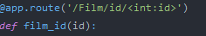

Links for each individual film including poster, overview and similar films.

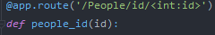

Links to an individual person with a bio and movies they may have been in, or known for.

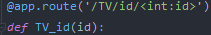

Links to an individual TV Show with an overview and similar TV Shows

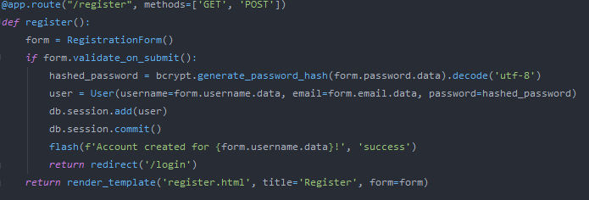

Register route which validates data entered and then adds the users to the database.

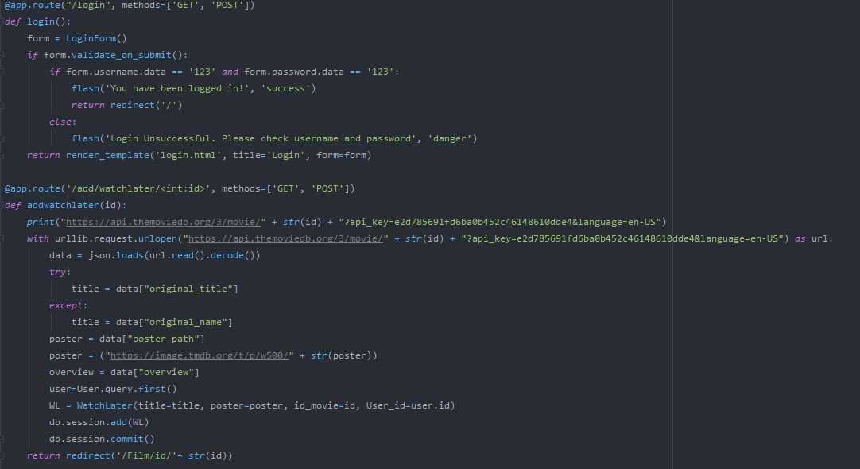

Login route to check if user exists however, I haven’t completed that yet.

Watch later route is for adding movies to the Watchlater table in the database.

@app.route('/Watchlater', methods=['GET', 'POST'])

This watch later route will allow for the user to view the movies that are currently in their watch later list.

**Subroutine and Variable Overview**

**Def index()**

|  |  |
| --- | --- |
| **Variable or array/dictionary name.** | **Description** |
| Data, Data1 and Data2 | These variables store the results returned from the query to the TMDB database. |
| popmov | This will contain the title and the poster image link of popular movies in a string format within the array called popmov. |
| linkpop | This will have the id of popular movies which will be later turned into a URL and passed to the HTML File. |
| strippedtitle | This will store title after the removal of the end of line character that is default. |
| topmov | This will contain the title and the poster image link of highly rated movies in a string format within the array called topmov. |
| linkpop1 | This will have the id of highly rated movies which will be later turned into a URL and passed to the HTML File. |
| upmov | This will contain the title and the poster image link of upcoming movies in a string format within the array called upmov. |
| Linkpop2 | This will have the id of upcoming movies which will be later turned into a URL and passed to the HTML File. |

**Def process_name()**

|  |  |
| --- | --- |
| **Variable or array/dictionary name.** | **Description** |
| type | This will store the data returned from the search bar for the type of request which includes options such as all, movie, tv and people. |
| name | This will store the request made by the user, which could include name of a person, tv show or a movie. |
| search | The variable will store the result of a .split() function on the name variable. |
| searchreq | This will store a plus symbol plus the addition of the search variable so it can be passed into a URL. |

**Def process()**

|  |  |
| --- | --- |
| **Variable or array/dictionary name.** | **Description** |
| num, type, name | These are passed into the subroutine when it is called through the URL. |
| title | This will contain the title or name of the person/TV show/Movie. |
| posterlink | Stores the image link of the poster of the Movie or TV show. If it is a person then it will an image of the person. |
| id | Stores the id of the specific Person, TV show or Movie. |
| pages | This contains the number of pages of data that is returned. |
| display_TV, display_Movie and display | Contains all the data needed for the display of the page. |

**Def film_id()**

|  |  |
| --- | --- |
| **Variable or array/dictionary name.** | **Description** |
| id | This is passed into the subroutine when it is called through the URL. |
| user | This will contain the current users’ details. |
| Movies1 | This will contain all the movies in the water later list of the user. |

**Def people_id()**

|  |  |
| --- | --- |
| **Variable or array/dictionary name.** | **Description** |
| id | This is passed into the subroutine when it is called through the URL. |
| data | Contains the data returned after a query was sent to the API |
| name | This will contain the name of the person |
| Image | This will store the image of the person if any are provided. |

**Def TV_id()**

|  |  |
| --- | --- |
| **Variable or array/dictionary name.** | **Description** |
| id | This is passed into the subroutine when it is called through the URL. |
| data | Contains the data returned after a query was sent to the API |
| poster | This will contain the image of the TV show poster. |
| Overview | This contains the overview of the TV Show |

**Def register()**

|  |  |
| --- | --- |
| **Variable or array/dictionary name.** | **Description** |
| form | This contains the form for registering including username, email and password. |
| hashed_password | This will contain the hashed version of the password entered into the form. |
| user | This will contain the details of the user once the data has been processed e.g. password hashing. |

**Def login()**

|  |  |
| --- | --- |
| **Variable or array/dictionary name.** | **Description** |
| form | This will load the data passed into the login form. |
| user | This will store the result of a search in the user database based on what the user has typed into the login form. |

**Def addwatchlater()**

|  |  |
| --- | --- |
| **Variable or array/dictionary name.** | **Description** |
| user | This will store the id of the current user. |
| id | Passed into the subroutine through the URL. |
| poster | This will store the poster of the movie. |
| overview | This will store the overview of the movie. |
| Movies1 | This will store the movies in the watch later list of the users. |
| WL | This will store the data of the new movie that will added to the database. |

**Def watchlater()**

|  |  |
| --- | --- |
| **Variable or array/dictionary name.** | **Description** |
| latmov | This will store the id of the movie. |
| linklat | This will store the title of the movie. |
| latpost | This will store the image link of the movie. |
| amountWL | This will store the length of the watch later list of the user. |

**Def recommendations()**

|  |  |
| --- | --- |
| **Variable or array/dictionary name.** | **Description** |
| df | This will store the data of the movie_database.csv file so it can be used later on in the subroutine. |
| Movies | This will store the movies in the users watch later list. |
| mov_newt | This will store the movies that are new and not already in the watch later list. |
| mov_old | This will store the movies that are already in the watch later list so that they aren’t recommended again. |
| mov_id | This will store the id of the movies that are recommended. |
| features | This is the list of features that will be compared to all the other movies in the .csv database. |
| cv | This will create an object of the CountVectorizer() class. |
| movie_user_likes | This is the movies the user likes |
| movie_index | This will store the result of a search of index using the title of the movie. |
| similar_movies | This will be the list of movies that are recommended and their score of similarity. |
| sorted_similar_movies | This will sort the movies in order of similarity. |
| id_mov | This will store the id of the movies that are recommended. |
| name_mov | This will store the title of the movie recommended. |
| pos_mov | This will store the poster of the movie recommended. |

**System Flowchart**

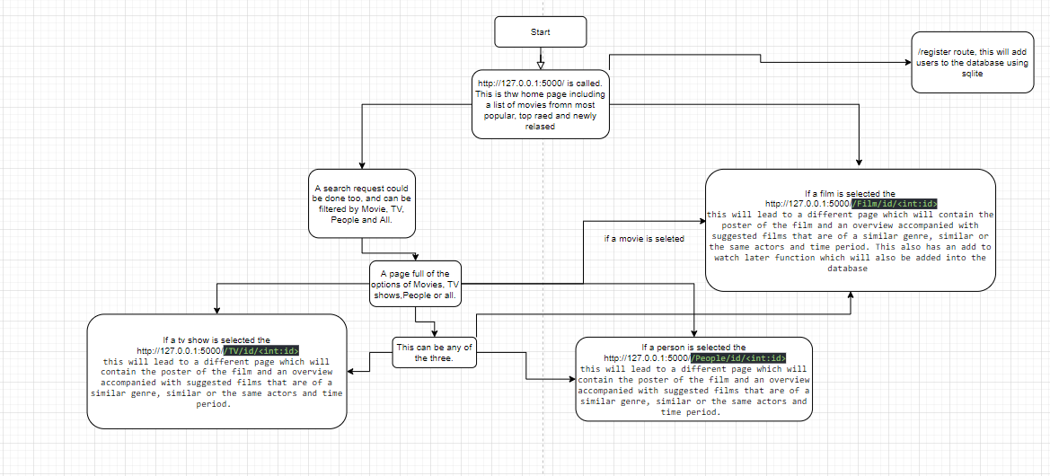

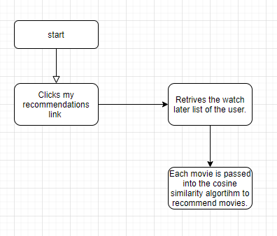

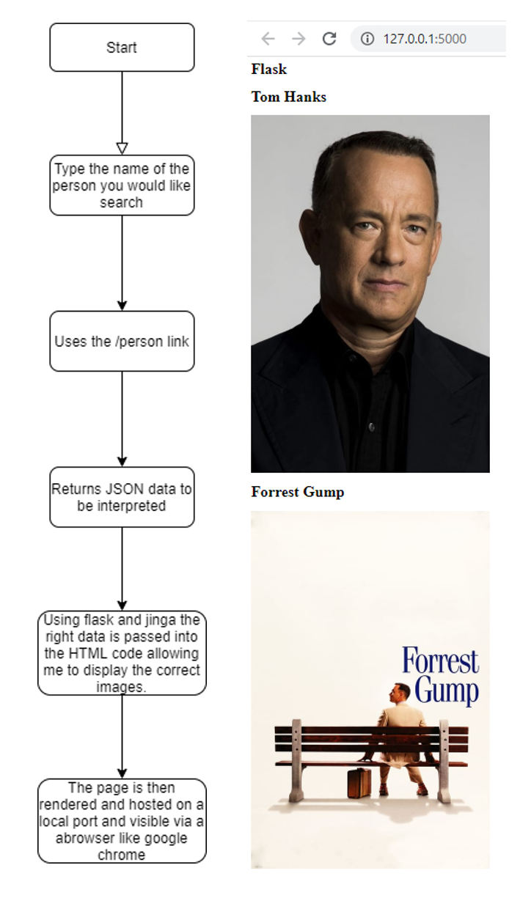

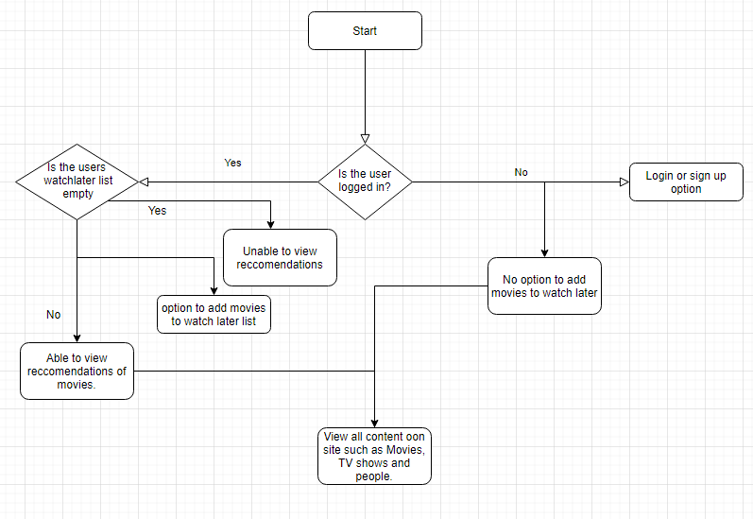

**Cosine similarity**

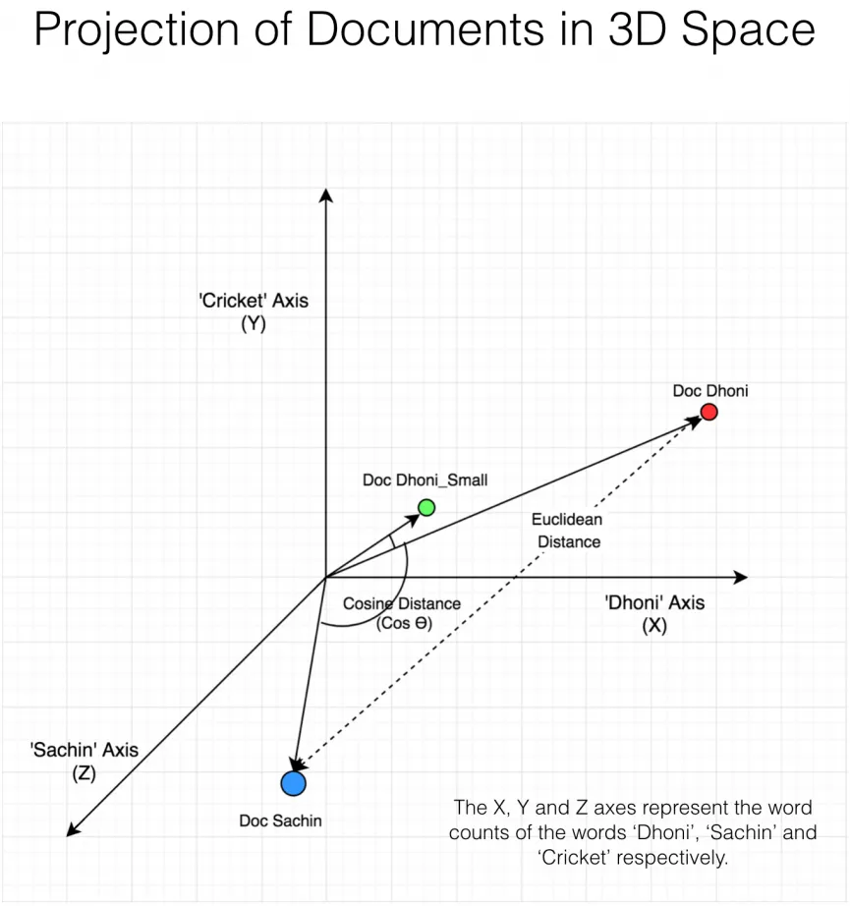

Cosine similarity is a machine learning technique to find the similarity between two vectors on a graph using certain factors for example in my case the factors would include key words, genres and directors of the movies. All the movies are put onto a graph matrix and the angular distance is computed between the selected movie and the other movies in the database. The cosine of the angular distances are calculated to get an answer between 1 and 0, the movies are then ranked in order of that to produce a recommendation. The cosine similarity metric was used as it is much faster, easier and effective to implement in comparison to some other algorithms.

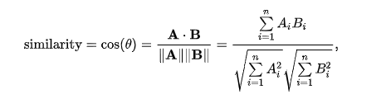

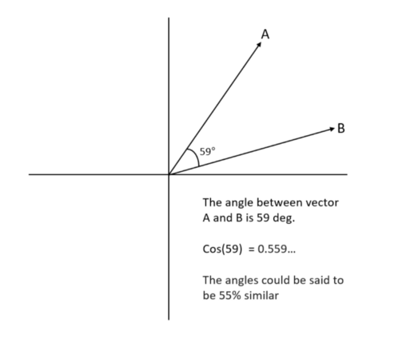As we can see in the example above A is a much better match for B then C is. Meaning if Movie B was in the users watch later list the Movie A is more likely to be recommended conserving how similar it is to Movie B in comparison to Movie C.

C

C

**Testing**

|  |  |  |  |
| --- | --- | --- | --- |
| **Objective tested:** | **Test description/ expected result:** | **Passed?** | **Evidence:** |
| Create a main page on the website with popular movies and access to login, sign up and search. I the user is logged in then there should be a log out button, watch later and my recommendations button. | Should show movies and search bar whether logged in or not. Plus the other buttons in accordance with whether the user is logged in or not. | Yes | Figure 1 |
| Show Movies page | Should have poster, description and similar movies and if logged in a watch later button. | Yes | Figure 2 |
| Show TV Show page | Should have poster, description and similar TV Shows | Yes | Figure 3 |
| Show People Page | Should have poster, description and Movies or TV Shows they are known for. | Yes | Figure 4 |
| Allow for search in all categories | Allow for the user to search in all categories along with individual categories such as Movies on its own. | Yes | <https://www.youtube.com/watch?v=mEOLjW4YuOE>  time stamp 3:41 |
| Be able to view Recommendations | Be able to view recommendations based upon movies the user has saved. | Yes | <https://www.youtube.com/watch?v=mEOLjW4YuOE>  time stamp 3:10 |
| Be able to remove a movie from the watch later list | To be able to press the X button and it to be removed from the list | Yes | <https://www.youtube.com/watch?v=mEOLjW4YuOE>  time stamp 1:05 |

All of these tests can be viewed in the YouTube video. <https://www.youtube.com/watch?v=mEOLjW4YuOE>

Figure 2

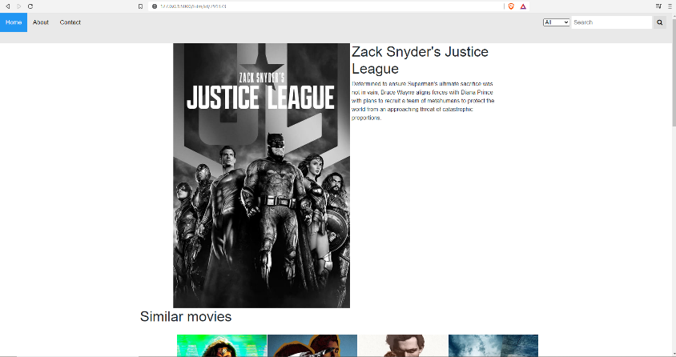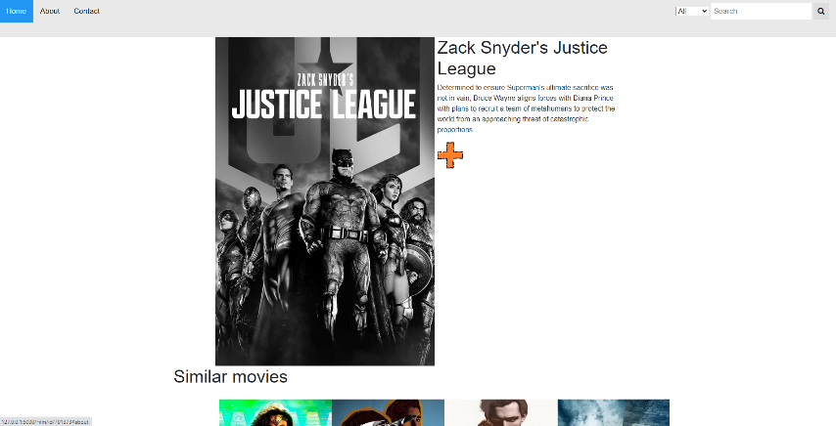

Figure 1

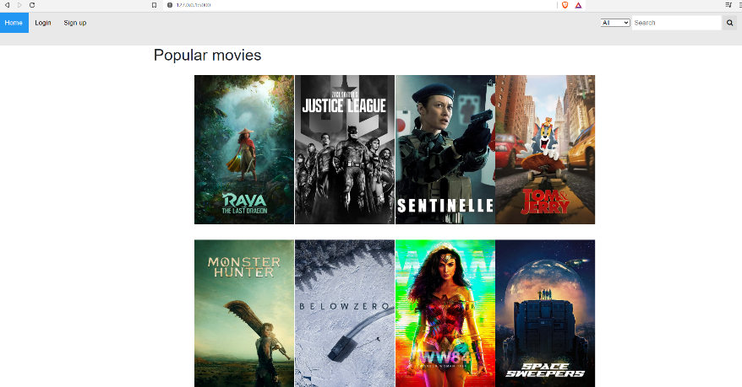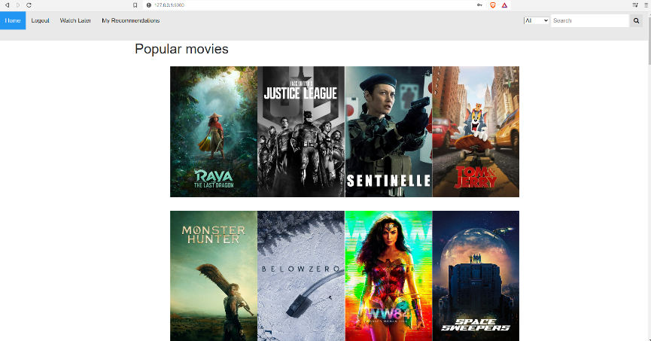

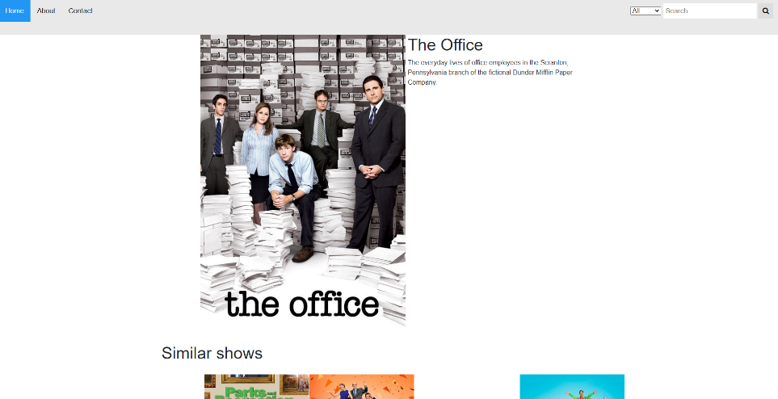

Figure 3

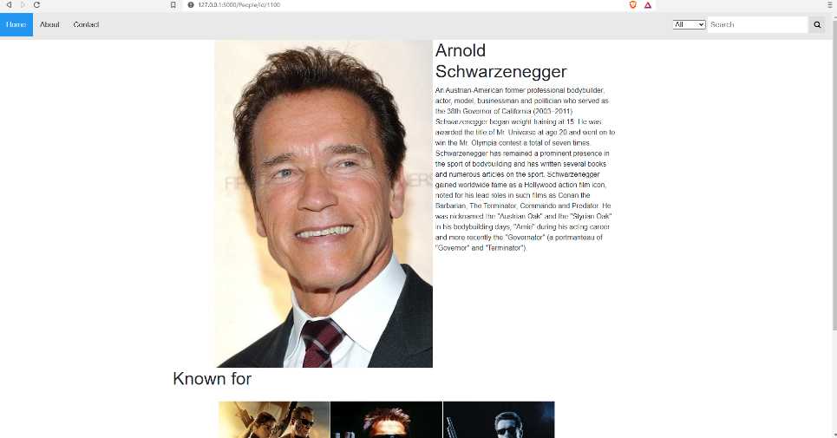

Figure 4

**Evaluation**

Overall, I think my project has met all the objectives set prior to me setting out to complete this project however no project is perfect as there are many areas I could have improved on.

|  |  |
| --- | --- |
| **Original Objective** | **Met/not met. Explain?** |
| To have a full personalised user experience where recommendations of movies are made using user’s data (e.g. preferences). | Met. I have allowed for a full personalised user experience with the help of my recommendation system. That uses a machine learning technique called cosine similarity to generate movie recommendations. |
| User accounts, including a login page. | Met. I have met the objective with the help of YouTube tutorials and libraries such as Flask login. |
| SQL databases with user details. | Met. I have met this objective with the help of SQLAlchemy and my model.py file. |
| Use of APIs from online movie databases (e.g. TMDB (the movie database). | Met. I used my API key given to me by TMDB to access their database so it can be used in my website. |
| Users can also use film search feature. | Met. This was also met with the help of the API along with the help of html python and some jinja code. |
| Algorithms used to determine movie recommendations. | Met. I have met this objective with the help of a machine learning techniques known as cosine similarity, which is fairly fast ad effective to use to recommend movies to the user. |

**User Feedback**

**Was the Website easy to use?**

Yes, the website was very easy to use and very self-explanatory as most buttons were labelled very clearly and visible.

**Were the recommendations good?**

Yes, the recommendations were quite good as they were all very similar to the movies, I had added into my watch later list.

**Overall, did the solution meet your needs?**

Yes, the website met all my needs in terms of recommendations and the searching of Movies, TV Shows, People etc.

**Any criticism?**

The recommendations could have been in a better order as in this system the most recent recommendations are found at the bottom.

**Comments of User Feedback**

Overall, I think the user was very positive towards the website, which allows me to come to the conclusions that this project was a success.

**Potential for Future Development**

One of the main functions of my program is the recommendation algorithm. I choose to use the cosine similarity metric, which makes the movie a vector on a graph using multiple categories, such as key words, genres and director.

Other algorithms such as SVD++ may have been better in terms of their RMSE scores however, the difference between them in terms of performance is minute. Also, cosine similarity is a lot faster to compute on a regular laptop PC making it ideal for this project.

Good recommendations systems include random recommendations along with similar movies, a system could also include recommendations based upon age, location etc. If I were to have more time to complete this project, I would work on that as well as possible improvements to the GUI.

**Appendix**

RUN.py

*from* Flask2 *import* app, db, bcrypt, models  
*from* flask_login *import* login_user, current_user, logout_user  
*# from flask_login import login_user, current_user, logout_user  
import* csv  
*import* urllib.request  
*import* json  
*import* pandas *as* pd  
*from* sklearn.feature_extraction.text *import* CountVectorizer  
*from* sklearn.metrics.pairwise *import* cosine_similarity  
*print*("sdjnskdjnf sdkjfsdf sdfkjsndf sdfskjnfd sdfkjsnd v v v v v v v v v v v v v v v v v v v v v v v v v v v v v v v v ")  
*print*(current_user)  
*print*("A A A A A A A A A A A A A A A A A A A A A A A A A A A A A A A A A A A A A A A A A A A A A A A A A A A A A A A A A ")  
*print*("This file should work")  
  
*def* add_movie(id, title):  
 f = *open*("C:/Users\Rathod\PycharmProjects\Flask stuff\Flask2\demo.txt", "r")  
 abc = f.read()  
 *with* urllib.request.urlopen("https://api.themoviedb.org/3/movie/" + *str*(  
 id) + "?api_key=e2d785691fd6ba0b452c46148610dde4&language=en-US") *as* url:  
 data = json.loads(url.read().decode())  
 a = *len*(data["genres"])  
 b = data["genres"]  
 _string = ""  
 *for* i *in range*(a):  
 _string = _string + b[i]["name"] + " "  
 *with* urllib.request.urlopen("https://api.themoviedb.org/3/movie/" + *str*(  
 id) + "/keywords?api_key=e2d785691fd6ba0b452c46148610dde4") *as* url:  
 data = json.loads(url.read().decode())  
 c = (data["keywords"])  
 _len = *len*(data["keywords"])  
 _string2 = ""  
 *for* i *in range*(_len):  
 _string2 = _string2 + c[i]["name"] + " "  
 *with* urllib.request.urlopen("https://api.themoviedb.org/3/movie/" + *str*(  
 id) + "/credits?api_key=e2d785691fd6ba0b452c46148610dde4&language=en-US") *as* url:  
 data = json.loads(url.read().decode())  
 _len1 = *len*(data["crew"])  
 director = ""  
 *for* i *in range*(_len1):  
 *if* data["crew"][i]["known_for_department"] == "Directing":  
 director = director + data["crew"][i]["name"]  
 *break  
 with open*('movie_dataset.csv', 'a', encoding="utf-8") *as* csvfile:  
 fieldnames = [*str*(abc), "", *str*(_string), "", *str*(id), *str*(_string2), "", *str*(title), "", "", "", "", "", "",  
 "", "", "", "", *str*(title), "", "", "", "", *str*(director)]  
 *print*(fieldnames)  
 writer = csv.writer(csvfile)  
 writer.writerow(fieldnames)  
 df = pd.read_csv("""C:/Users\Rathod\PycharmProjects\Flask stuff\Flask2\movie_dataset.csv""")  
 b = *int*(abc) + 1  
 f = *open*("demo.txt", "w")  
 f.write(*str*(b))  
 f.close()  
  
  
*def* get_title_from_index(index):  
 df = pd.read_csv("""C:/Users\Rathod\PycharmProjects\Flask stuff\Flask2\movie_dataset.csv""")  
 *return* df[df.index == index]["title"].values[0]  
  
  
*def* get_index_from_title(title):  
 df = pd.read_csv("""C:/Users\Rathod\PycharmProjects\Flask stuff\Flask2\movie_dataset.csv""")  
 *return* df[df.title == title]["index"].values[0]  
*for* i *in range*(18):  
 *print*(i+1)  
 df = pd.read_csv("""C:/Users\Rathod\PycharmProjects\Flask stuff\Flask2\movie_dataset.csv""")  
 *try*:  
 Movies = models.WatchLater.query.filter_by(User_id=i+1).all()  
 *except*:  
 *continue* amountWL = *len*(Movies)  
 *for* i *in range*(amountWL):  
 *try*:  
 get_index_from_title(Movies[i].title)  
 *except IndexError*:  
 add_movie(Movies[i].id_movie, Movies[i].title)  
  
  
  
  
*def* run(runfile):  
 *with open*(runfile, "r") *as* rnf:  
 *exec*(rnf.read())  
run("C:/Users/Rathod/PycharmProjects/Flask stuff/run.py")

run.py

*from* Flask2 *import* app  
*if* __name__ == "__main__":  
 app.run(debug=*True*)

routes.py

*from* flask *import* render_template, request, redirect, url_for, flash, redirect  
*from* Flask2 *import* app, db, bcrypt, models  
*from* Flask2.forms *import* RegistrationForm, LoginForm  
*from* Flask2.models *import* User, WatchLater, Liked  
*import* urllib.request  
*import* json  
*from* flask_login *import* login_user, current_user, logout_user  
*import* pandas *as* pd  
*import* numpy *as* np  
*import* csv  
*import* sys  
*import* os  
*from* sklearn.feature_extraction.text *import* CountVectorizer  
*from* sklearn.metrics.pairwise *import* cosine_similarity  
  
*#This is th intial home page*@app.route('/')  
*def* index():  
 *print*("BDKHBDKSKJBSKJBSKJBSKJB KJHKSJHKSJHKJSH KJHKJH KJHKASJHKJ HKjhkdjhf ksdj fhksjdhf kjshdfkhKSJHFDKSJDHFKSJ DKFJSKDF KSDJF SKDJF SKDJF SKDJF SKDJF HSDKJF SDKFJSDKFJSDKFJSD HFKSJDFSKDJF SKDJFSKDJF HSKDJFHSKDJFSKDJF SKDJFKSJDF ")  
 *print*(current_user)  
 *print*("BDKHBDKSKJBSKJBSKJBSKJB KJHKSJHKSJHKJSH KJHKJH KJHKASJHKJ HKjhkdjhf ksdj fhksjdhf kjshdfkhKSJHFDKSJDHFKSJ DKFJSKDF KSDJF SKDJF SKDJF SKDJF SKDJF HSDKJF SDKFJSDKFJSDKFJSD HFKSJDFSKDJF SKDJFSKDJF HSKDJFHSKDJFSKDJF SKDJFKSJDF ")  
 *#This is when i will retirive the data from the api, this specific query will be popular movies which are selected by tmdb  
 with* urllib.request.urlopen("https://api.themoviedb.org/3/movie/popular?api_key=e2d785691fd6ba0b452c46148610dde4&language=en-US&page=1") *as* url:  
 data1 = json.loads(url.read().decode())  
 data2 = data1["results"]  
 *#these variables will store the info needed to be displayed and passed to the html file* popmov=[]  
 linkpop=[]  
 *for* i *in range*(20):  
 *# print(i)  
 try*:  
 *# print(data2[i])* data3 = data2[i]  
 *except*:  
 *continue  
 try*:  
 *print*(data3["original_name"] + ":")  
 *if* "/n" *in* data3["original_name"]:  
 strippedtitle=data3["original_name"].replace("/n", " ")  
 popmov.append(strippedtitle)  
 *else*:  
 popmov.append(data3["original_name"])  
 *except*:  
 *print*(data3["original_title"] + ":")  
 *if* "/n" *in* data3["original_title"]:  
 strippedtitle=data3["original_title"].replace("/n", " ")  
 popmov.append(strippedtitle)  
 *else*:  
 popmov.append(data3["original_title"])  
 linkpop.append(data3["id"])  
 *print*(data3["overview"])  
 *print*("https://image.tmdb.org/t/p/w500/" + *str*(data3["poster_path"]))  
 popmov.append("https://image.tmdb.org/t/p/w500/" + *str*(data3["poster_path"]))  
  
 *with* urllib.request.urlopen("https://api.themoviedb.org/3/movie/top_rated?api_key=e2d785691fd6ba0b452c46148610dde4&language=en-US&page=1") *as* url:  
 data1 = json.loads(url.read().decode())  
 data2 = data1["results"]  
 topmov=[]  
 linkpop1 = []  
 *for* i *in range*(20):  
 *# print(i)  
 try*:  
 *# print(data2[i])* data3 = data2[i]  
 *except*:  
 *continue  
 try*:  
 *print*(data3["original_name"] + ":")  
 topmov.append(data3["original_name"])  
 *except*:  
 *print*(data3["original_title"] + ":")  
 topmov.append(data3["original_title"])  
 linkpop1.append(data3["id"])  
 *print*(data3["overview"])  
 *print*("https://image.tmdb.org/t/p/w500/" + *str*(data3["poster_path"]))  
 topmov.append("https://image.tmdb.org/t/p/w500/" + *str*(data3["poster_path"]))  
  
 *with* urllib.request.urlopen("https://api.themoviedb.org/3/movie/upcoming?api_key=e2d785691fd6ba0b452c46148610dde4&language=en-US&page=1") *as* url:  
 data1 = json.loads(url.read().decode())  
 data2 = data1["results"]  
 upmov=[]  
 linkpop2 = []  
 *for* i *in range*(20):  
 *# print(i)  
 try*:  
 *# print(data2[i])* data3 = data2[i]  
 *except*:  
 *continue  
 try*:  
 *print*(data3["original_name"] + ":")  
 upmov.append(data3["original_name"])  
 *except*:  
 *print*(data3["original_title"] + ":")  
 upmov.append(data3["original_title"])  
 linkpop2.append(data3["id"])  
 *print*(data3["overview"])  
 *print*("https://image.tmdb.org/t/p/w500/" + *str*(data3["poster_path"]))  
 upmov.append("https://image.tmdb.org/t/p/w500/" + *str*(data3["poster_path"]))  
 *return* render_template('index.html', popmov=popmov, topmov=topmov, upmov=upmov,linkpop=linkpop, linkpop1=linkpop1, linkpop2=linkpop2)  
  
@app.route('/extypolhffhlhqsompjqxbqhunccgktnknprxgmaypmlpiuaiaqxhsigvklpysofywchxztxouhicmelqiyrddzelvgoaccjeak/', methods=['POST', 'GET'])  
*def* process_name():  
 type = request.form['cars']  
 name = request.form['name']  
 search = name.split()  
 *global* searchreq  
 searchreq = "+".join(search)  
 a = '/process/1'  
 *return* redirect('/process_name/type='+ type + '/page=1/query='+ searchreq)  
  
  
@app.route('/process_name/type=<type>/page=<num>/query=<name>', methods = ['POST','GET'])  
*def* process(num, type, name):  
 *global* data  
 *global* name1  
 *global* poster  
 *global* twd  
 *if* type == "Person":  
 *with* urllib.request.urlopen("https://api.themoviedb.org/3/search/person?sort_by=popularity.desc&api_key=e2d785691fd6ba0b452c46148610dde4&query=" + name + "&page=" + *str*(num) + "&sort_by=popularity.desc") *as* url:  
 *print*("https://api.themoviedb.org/3/search/person?sort_by=popularity.desc&api_key=e2d785691fd6ba0b452c46148610dde4&query=" + name + "&page=1" + "&sort_by=popularity.desc")  
 display=[]  
 data = json.loads(url.read().decode())  
 *print*(data)  
 title = []  
 posterlink = []  
 id = []  
 pages = data['total_pages']  
 *if* data['total_results']<20:  
 a=data['total_results']  
 *else*:  
 a=20  
 data1 = data['results']  
 *for* i *in range*(a):  
 data2 = data1[i]  
 id.append(data2['id'])  
 knownfor = data2['known_for']  
 *print*("Known for:")  
 *for* i *in range*(3):  
 *try*:  
 *# print(i)* twd = (knownfor[i])  
 *# print(str(i) + " " + str(twd))  
 # stuff=""  
 try*:  
 *# stuff += (twd['original_name'])* title.append(twd['original_name'])  
 *if* twd['poster_path'] == "None":  
 posterlink.append("https://i.ibb.co/1n24z5s/Moodvie.png")  
 *else*:  
 posterlink.append("https://image.tmdb.org/t/p/w500/" + *str*(twd['poster_path']))  
 *print*(twd['original_name'] + " " + "https://image.tmdb.org/t/p/w500/" + *str*(  
 twd['poster_path']))  
 *except*:  
 title.append(twd['original_title'])  
 *if* twd['poster_path'] == "None":  
 posterlink.append("https://i.ibb.co/1n24z5s/Moodvie.png")  
 *else*:  
 posterlink.append("https://image.tmdb.org/t/p/w500/" + *str*(twd['poster_path']))  
 *# stuff += (twd['original_title'])  
 print*(twd['original_title'] + " " + "https://image.tmdb.org/t/p/w500/" + *str*(  
 twd['poster_path']))  
 *except*:  
 *print*("")  
 *# print(data1)  
 # print(data2)  
 print*(data2['name'])  
 name1 = data2['name']  
 poster = "https://image.tmdb.org/t/p/w500/" + *str*(data2['profile_path'])  
 *print*("https://image.tmdb.org/t/p/w500/" + *str*(data2['profile_path']))  
 display.append(name1)  
 display.append("https://image.tmdb.org/t/p/w500/" + *str*(data2['profile_path']))  
 *print*(display)  
 *return* render_template('new.html', display=display, title=title, posterlink=posterlink, id=id, name=name, pages=pages, type=type, a=a)  
 *elif* type == "Movie":  
 display = []  
 id=[]  
 *with* urllib.request.urlopen("https://api.themoviedb.org/3/search/movie?sort_by=popularity.desc&&include_adult=false&api_key=e2d785691fd6ba0b452c46148610dde4&language=en-US&page=" + *str*(num) + "&query=" + name) *as* url:  
 data = json.loads(url.read().decode())  
 data1=data['results']  
 pages = data['total_pages']  
 *if* data['total_results']<20:  
 a=data['total_results']  
 *else*:  
 a=20  
 *for* i *in range*(a):  
 *try*:  
 *# print(data2[i])* data3 = data1[i]  
 *except*:  
 *continue  
 try*:  
 display.append(data3["original_name"] + ":")  
 *except*:  
 display.append(data3["original_title"] + ":")  
 id.append(data3["id"])  
 display.append("https://image.tmdb.org/t/p/w500/" + *str*(data3["poster_path"]))  
 *return* render_template('new.html', display=display, id=id, type=type, pages=pages, name=name, a=a)  
 *elif* type == "TV":  
 display = []  
 id=[]  
 *with* urllib.request.urlopen("https://api.themoviedb.org/3/search/tv?sort_by=popularity.desc&api_key=e2d785691fd6ba0b452c46148610dde4&language=en-US&page=" + *str*(num) + "&include_adult=false&query=" + name) *as* url:  
 data = json.loads(url.read().decode())  
 data1=data['results']  
 pages = data['total_pages']  
 *if* data['total_results']<20:  
 a=data['total_results']  
 *else*:  
 a=20  
 *for* i *in range*(a):  
 *try*:  
 *# print(data2[i])* data3 = data1[i]  
 *except*:  
 *continue  
 try*:  
 display.append(data3["original_name"] + ":")  
 *except*:  
 display.append(data3["original_title"] + ":")  
 id.append(data3["id"])  
 display.append("https://image.tmdb.org/t/p/w500/" + *str*(data3["poster_path"]))  
 *return* render_template('new.html', display=display, id=id, type=type, pages=pages, name=name, a=a)  
 *elif* type == "All":  
 *with* urllib.request.urlopen("https://api.themoviedb.org/3/search/person?sort_by=popularity.desc&api_key=e2d785691fd6ba0b452c46148610dde4&query=" + name + "&page=" + *str*(num) + "&sort_by=popularity.desc") *as* url:  
 *print*("https://api.themoviedb.org/3/search/person?sort_by=popularity.desc&api_key=e2d785691fd6ba0b452c46148610dde4&query=" + name + "&page=1" + "&sort_by=popularity.desc")  
 display_person=[]  
 data = json.loads(url.read().decode())  
 *print*(data)  
 title = []  
 posterlink = []  
 id_person = []  
 pages = data['total_pages']  
 *if* data['total_results']<20:  
 a_P=data['total_results']  
 *else*:  
 a_P=20  
 data1 = data['results']  
 *for* i *in range*(a_P):  
 data2 = data1[i]  
 id_person.append(data2['id'])  
 knownfor = data2['known_for']  
 *print*("Known for:")  
 *for* i *in range*(3):  
 *try*:  
 *# print(i)* twd = (knownfor[i])  
 *# print(str(i) + " " + str(twd))  
 # stuff=""  
 try*:  
 *# stuff += (twd['original_name'])* title.append(twd['original_name'])  
 *if* twd['poster_path'] == "None":  
 posterlink.append("https://i.ibb.co/1n24z5s/Moodvie.png")  
 *else*:  
 posterlink.append("https://image.tmdb.org/t/p/w500/" + *str*(twd['poster_path']))  
 *print*(twd['original_name'] + " " + "https://image.tmdb.org/t/p/w500/" + *str*(  
 twd['poster_path']))  
 *except*:  
 title.append(twd['original_title'])  
 *if* twd['poster_path'] == "None":  
 posterlink.append("https://i.ibb.co/1n24z5s/Moodvie.png")  
 *else*:  
 posterlink.append("https://image.tmdb.org/t/p/w500/" + *str*(twd['poster_path']))  
 *# stuff += (twd['original_title'])  
 print*(twd['original_title'] + " " + "https://image.tmdb.org/t/p/w500/" + *str*(  
 twd['poster_path']))  
 *except*:  
 *print*("")  
 *# print(data1)  
 # print(data2  
 print*(data2['name'])  
 name1 = data2['name']  
 poster = "https://image.tmdb.org/t/p/w500/" + *str*(data2['profile_path'])  
 *print*("https://image.tmdb.org/t/p/w500/" + *str*(data2['profile_path']))  
 display_person.append(name1)  
 display_person.append("https://image.tmdb.org/t/p/w500/" + *str*(data2['profile_path']))  
 *print*(display_person)  
  
 display_TV = []  
 id_TV = []  
 *with* urllib.request.urlopen(  
 "https://api.themoviedb.org/3/search/tv?sort_by=popularity.desc&api_key=e2d785691fd6ba0b452c46148610dde4&language=en-US&page=" + *str*(  
 num) + "&include_adult=false&query=" + name) *as* url:  
 data = json.loads(url.read().decode())  
 data1 = data['results']  
 pages = data['total_pages']  
 *if* data['total_results'] < 20:  
 a_T = data['total_results']  
 *else*:  
 a_T = 20  
 *for* i *in range*(a_T):  
 *try*:  
 *# print(data2[i])* data3 = data1[i]  
 *except*:  
 *continue  
 try*:  
 display_TV.append(data3["original_name"] + ":")  
 *except*:  
 display_TV.append(data3["original_title"] + ":")  
 id_TV.append(data3["id"])  
 display_TV.append("https://image.tmdb.org/t/p/w500/" + *str*(data3["poster_path"]))  
 display_Movie = []  
 id_Movie = []  
 *with* urllib.request.urlopen("https://api.themoviedb.org/3/search/movie?sort_by=popularity.desc&&include_adult=false&api_key=e2d785691fd6ba0b452c46148610dde4&language=en-US&page=" + *str*(num) + "&query=" + name) *as* url:  
 data = json.loads(url.read().decode())  
 data1=data['results']  
 pages = data['total_pages']  
 *if* data['total_results']<20:  
 a_M=data['total_results']  
 *else*:  
 a_M=20  
 *for* i *in range*(a_M):  
 *try*:  
 *# print(data2[i])* data3 = data1[i]  
 *except*:  
 *continue  
 try*:  
 display_Movie.append(data3["original_name"] + ":")  
 *except*:  
 display_Movie.append(data3["original_title"] + ":")  
 id_Movie.append(data3["id"])  
 display_Movie.append("https://image.tmdb.org/t/p/w500/" + *str*(data3["poster_path"]))  
 *if* a_M > 4:  
 a_M = 4  
 *if* a_P > 4:  
 a_P = 4  
 *if* a_T > 4:  
 a_T=4  
  
 *return* render_template('Multi.html', display_Movie=display_Movie, id_Movie=id_Movie, display_TV=display_TV, id_TV=id_TV, display_person=display_person, id_person=id_person, name=name, a_M=a_M, a_P=a_P, a_T=a_T,)  
  
  
  
  
  
@app.route('/Film/id/<int:id>')  
*def* film_id(id):  
 *try*:  
 user = current_user  
 Movies1 = WatchLater.query.filter_by(User_id=user.id, id_movie=id).all()  
 value=2  
 *except*:  
 value=1  
 *try*:  
 *with* urllib.request.urlopen("https://api.themoviedb.org/3/movie/"+ *str*(id) +"?api_key=e2d785691fd6ba0b452c46148610dde4&language=en-US") *as* url:  
 data = json.loads(url.read().decode())  
 *print*(data["adult"])  
 *if* data["adult"]==*True*:  
 stop=1  
 *print*(stop)  
 *return* render_template('Film.html', stop=stop)  
 *else*:  
 stop=2  
 *print*(stop)  
 *try*:  
 title = data["original_title"]  
 *except*:  
 title = data["original_name"]  
 poster = data["poster_path"]  
 poster=("https://image.tmdb.org/t/p/w500/" + *str*(poster))  
 overview = data["overview"]  
 *with* urllib.request.urlopen("https://api.themoviedb.org/3/movie/" + *str*(id) + "/recommendations?api_key=e2d785691fd6ba0b452c46148610dde4&adult=false&language=en-US&page=1") *as* url:  
 data1 = json.loads(url.read().decode())  
 amount=data1["total_results"]  
 *print*(amount)  
 data2 = data1["results"]  
 display = []  
 linkpop = []  
 *if* amount==0:  
 *pass  
 else*:  
 *for* i *in range*(amount):  
 *# print(i)  
 try*:  
 *# print(data2[i])* data3 = data2[i]  
 *except*:  
 *continue* linkpop.append(data3["id"])  
 *try*:  
 *print*(data3["original_title"] + ":")  
 display.append(data3["original_title"])  
 *print*(data3["overview"])  
 *print*("https://image.tmdb.org/t/p/w500/" + *str*(data3["poster_path"]))  
 display.append("https://image.tmdb.org/t/p/w500/" + *str*(data3["poster_path"]))  
 *except*:  
 *print*(data3["original_name"] + ":")  
 display.append(data3["original_name"])  
 *print*(data3["overview"])  
 *print*("https://image.tmdb.org/t/p/w500/" + *str*(data3["poster_path"]))  
 display.append("https://image.tmdb.org/t/p/w500/" + *str*(data3["poster_path"]))  
 *if* value==1:  
 *return* render_template('Film.html', title=title, id=id, poster=poster, overview=overview,  
 display=display, linkpop=linkpop, stop=stop, thing=0)  
 *else*:  
 *if* Movies1 == []:  
 *return* render_template('Film.html', title=title, id=id, poster=poster, overview=overview,  
 display=display, linkpop=linkpop, stop=stop, thing=1)  
 *else*:  
 *return* render_template('Film.html', title=title, id=id, poster=poster, overview=overview, display=display, linkpop=linkpop,stop=stop, thing=2)  
 *except*:  
 stop = 1  
 *return* render_template('Film.html', stop=stop)  
@app.route('/People/id/<int:id>')  
*def* people_id(id):  
 *try*:  
 *with* urllib.request.urlopen("https://api.themoviedb.org/3/person/" + *str*(id) + "?api_key=e2d785691fd6ba0b452c46148610dde4&language=en-US") *as* url:  
 data = json.loads(url.read().decode())  
 name=data["name"]  
 description=data["biography"]  
 search = name.split()  
 image="https://image.tmdb.org/t/p/w500/" + *str*(data["profile_path"])  
 searchreq = "+".join(search)  
 *print*(searchreq)  
 *except*:  
 *print*("")  
 *with* urllib.request.urlopen("https://api.themoviedb.org/3/search/person?sort_by=popularity.desc&api_key=e2d785691fd6ba0b452c46148610dde4&query=" + searchreq + "&page=1&sort_by=popularity.desc") *as* url:  
 *print*("https://api.themoviedb.org/3/search/person?sort_by=popularity.desc&api_key=e2d785691fd6ba0b452c46148610dde4&query=" + searchreq + "&page=1" + "&sort_by=popularity.desc")  
 data = json.loads(url.read().decode())  
 *print*(data)  
 title=[]  
 posterlink=[]  
 id=[]  
 media=[]  
 data1 = data['results']  
 data2 = data1[0]  
 knownfor = data2['known_for']  
 *print*("Known for:")  
 *for* i *in range*(3):  
 *try*:  
 *# print(i)* twd = (knownfor[i - 1])  
 *# print(str(i) + " " + str(twd))  
 # stuff=""  
 try*:  
 *# stuff += (twd['original_name'])* title.append(twd['original_name'])  
 posterlink.append("https://image.tmdb.org/t/p/w500/" + *str*(twd['poster_path']))  
 *print*(twd['original_name'] + " " + "https://image.tmdb.org/t/p/w500/" + *str*(twd['poster_path']))  
 *except*:  
 title.append(twd['original_title'])  
 posterlink.append("https://image.tmdb.org/t/p/w500/" + *str*(twd['poster_path']))  
 *# stuff += (twd['original_title'])  
 print*(twd['original_title'] + " " + "https://image.tmdb.org/t/p/w500/" + *str*(twd['poster_path']))  
 *except*:  
 *print*("")  
 media.append(twd['media_type'])  
 id.append(twd['id'])  
 *print*(id)  
 *# print(data1)  
 # print(data2  
 return* render_template('Person.html', name=name, description=description, image=image, title=title, posterlink=posterlink, id=id,media=media)  
  
@app.route('/TV/id/<int:id>')  
*def* TV_id(id):  
 *with* urllib.request.urlopen("https://api.themoviedb.org/3/tv/"+ *str*(id) +"?api_key=e2d785691fd6ba0b452c46148610dde4&language=en-US") *as* url:  
 data = json.loads(url.read().decode())  
 *try*:  
 title = data["original_title"]  
 *except*:  
 title = data["original_name"]  
 poster = data["poster_path"]  
 poster=("https://image.tmdb.org/t/p/w500/" + *str*(poster))  
 overview = data["overview"]  
 *with* urllib.request.urlopen("https://api.themoviedb.org/3/tv/" + *str*(id) + "/recommendations?api_key=e2d785691fd6ba0b452c46148610dde4&adult=false&language=en-US&page=1") *as* url:  
 data1 = json.loads(url.read().decode())  
 amount=data1["total_results"]  
 *print*(amount)  
 data2 = data1["results"]  
 display = []  
 linkpop = []  
 *if* amount==0:  
 *pass  
 else*:  
 *for* i *in range*(amount):  
 *# print(i)  
 try*:  
 *# print(data2[i])* data3 = data2[i]  
 *except*:  
 *continue* linkpop.append(data3["id"])  
 *try*:  
 *print*(data3["original_title"] + ":")  
 display.append(data3["original_title"])  
 *print*(data3["overview"])  
 *print*("https://image.tmdb.org/t/p/w500/" + *str*(data3["poster_path"]))  
 display.append("https://image.tmdb.org/t/p/w500/" + *str*(data3["poster_path"]))  
 *except*:  
 *print*(data3["original_name"] + ":")  
 display.append(data3["original_name"])  
 *print*(data3["overview"])  
 *print*("https://image.tmdb.org/t/p/w500/" + *str*(data3["poster_path"]))  
 display.append("https://image.tmdb.org/t/p/w500/" + *str*(data3["poster_path"]))  
 *return* render_template('TV.html', title=title, poster=poster, overview=overview, display=display, linkpop=linkpop)  
*# @app.route('/demo1')  
# def demoOne():  
#  
# return render_template('demoOne.html', names=rows)  
  
# @app.route('/api/addEntry', methods = ['POST'])  
# def addEntry():  
# name =request.form['name']  
# age=request.form['age']  
# rows.append([name,age])  
# print("Recieved request to addEntry " + request.form["name"])  
# return jsonify({"success": True, "entries": rows})*@app.route("/register", methods=['GET', 'POST'])  
*def* register():  
 *if* current_user.is_authenticated:  
 *return* redirect('/')  
 form = RegistrationForm()  
 *if* form.validate_on_submit():  
 hashed_password = bcrypt.generate_password_hash(form.password.data).decode('utf-8')  
 user = User(username=form.username.data, email=form.email.data, password=hashed_password)  
 db.session.add(user)  
 db.session.commit()  
 flash(f'Account created for {form.username.data}!', 'success')  
 *return* redirect('/login')  
 *return* render_template('register.html', title='Register', form=form)  
  
@app.route("/login", methods=['GET', 'POST'])  
*def* login():  
 *if* current_user.is_authenticated:  
 *return* redirect('/')  
 form = LoginForm()  
 *if* form.validate_on_submit():  
 user = User.query.filter_by(username=form.username.data).first()  
 *if* user *and* bcrypt.check_password_hash(user.password, form.password.data):  
 login_user(user, remember=form.remember.data)  
 *return* redirect('/')  
 *else*:  
 flash('Login Unsuccessful. Please check username and password', 'danger')  
 *return* render_template('login.html', title='Login', form=form)  
  
@app.route('/add/watchlater/<int:id>', methods=['GET', 'POST'])  
*def* addwatchlater(id):  
 *try*:  
 user=current_user.id  
 *except*:  
 flash('Please login before adding item into your watch later list', 'danger')  
 *return* redirect('/login')  
  
  
 *print*("https://api.themoviedb.org/3/movie/" + *str*(id) + "?api_key=e2d785691fd6ba0b452c46148610dde4&language=en-US")  
 *with* urllib.request.urlopen("https://api.themoviedb.org/3/movie/" + *str*(id) + "?api_key=e2d785691fd6ba0b452c46148610dde4&language=en-US") *as* url:  
 data = json.loads(url.read().decode())  
 *try*:  
 title = data["original_title"]  
 *except*:  
 title = data["original_name"]  
 poster = data["poster_path"]  
 poster = ("https://image.tmdb.org/t/p/w500/" + *str*(poster))  
 overview = data["overview"]  
 user=current_user  
 Movies1 = WatchLater.query.filter_by(User_id=user.id, id_movie=id).all()  
 *if* Movies1==[]:  
 WL = WatchLater(title=title, poster=poster, id_movie=id, User_id=user.id)  
 db.session.add(WL)  
 db.session.commit()  
 *print*("added kdjnskjdksjd skdjfnksjndf sdjknfksjd fksdjfnskdf skdjnskjdf skdfnskdfjns ")  
 *else*:  
 del23 = WatchLater.query.filter_by(User_id=6, id_movie=id).delete()  
 db.session.commit()  
 *print*("deleted ssojdnfksjdf sdkjsd sodiskd sdskd lsdf sd slkdfjsldlskdjflskdf sdslkdfjsld fsdfsd")  
  
  
 *# try:  
 # df = pd.read_csv("""C:/Users\Rathod\PycharmProjects\Flask stuff\Flask2\movie_dataset.csv""")  
 # return df[df.title == title]["index"].values[0]  
 # except:  
 # Flask2.RecTen.add_movie(id,title)  
 return* redirect('/Film/id/'+ *str*(id))  
  
@app.route('/Watchlater', methods=['GET', 'POST'])  
*def* watchlater():  
 latmov=[]  
 linklat=[]  
 latpost=[]  
 user=current_user  
 Movies=WatchLater.query.filter_by(User_id=user.id).all()  
 *print*(*len*(Movies))  
 *# print(Movies[0].title)* amountWL=*len*(Movies)  
 *for* i *in range*(amountWL):  
 latmov.append(Movies[i].id_movie)  
 linklat.append(Movies[i].title)  
 latpost.append(Movies[i].poster)  
 *# Movies1 = WatchLater.query.filter_by(User_id=user.id, id_movie=497582).all()  
 # print(Movies1)  
 print*(latmov)  
 *print*(linklat)  
 *print*(latpost)  
 *return* render_template('Watchlater.html',latmov=latmov, linklat=linklat, latpost=latpost, amountWL=amountWL)  
  
@app.route("/logout")  
*def* logout():  
 logout_user()  
 *return* redirect('/')  
  
  
@app.route("/recommendations")  
*def* recommendations():  
 *def* get_title_from_index(index):  
 df = pd.read_csv("""C:/Users\Rathod\PycharmProjects\Flask stuff\Flask2\movie_dataset.csv""")  
 *return* df[df.index == index]["title"].values[0]  
  
 *def* get_index_from_title(title):  
 df = pd.read_csv("""C:/Users\Rathod\PycharmProjects\Flask stuff\Flask2\movie_dataset.csv""")  
 *return* df[df.title == title]["index"].values[0]  
  
  
 user=current_user  
 df = pd.read_csv("""C:/Users\Rathod\PycharmProjects\Flask stuff\Flask2\movie_dataset.csv""")  
 Movies = models.WatchLater.query.filter_by(User_id=user.id).all()  
 amountWL = *len*(Movies)  
 mov_newt=[]  
 mov_old=[]  
 *for* i *in range*(amountWL):  
 *try*:  
 get_index_from_title(Movies[i].title)  
 *except IndexError*:  
 mov_newt.append(Movies[i].title)  
 *continue* mov_old.append(Movies[i].id_movie)  
 length=*len*(Movies)  
 mov_id = []  
 *for* i *in range* (length):  
 *if* Movies[i].title *in* mov_newt:  
 *continue  
 else*:  
 df = pd.read_csv("""C:/Users\Rathod\PycharmProjects\Flask stuff\Flask2\movie_dataset.csv""")  
 *print*(df)  
 features = ['keywords', 'genres', 'director']  
 *for* feature *in* features:  
 df[feature] = df[feature].fillna('')  
  
 *def* combine_features(row):  
 *return* (row['keywords'] + " " + row['genres'] + " " + row['director'])  
  
 df["combined_features"] = df.apply(combine_features, axis=1)  
  
 cv = CountVectorizer()  
 count_matrix = cv.fit_transform(df["combined_features"])  
 cosine_sim = cosine_similarity(count_matrix)  
  
 movie_user_likes = Movies[i].title  
 *print*(movie_user_likes)  
  
 movie_index = get_index_from_title(movie_user_likes)  
  
 similar_movies = *list*(*enumerate*(cosine_sim[movie_index]))  
  
 sorted_similar_movies = *sorted*(similar_movies, key=*lambda* x: x[1], reverse=*True*)  
  
 i = 0  
 *print*("old movies: ")  
 *print*(mov_old)  
 *for* movie *in* sorted_similar_movies:  
 *print*(df[df.index == (movie[0])]["id"].values[0])  
 *if* df[df.index == (movie[0])]["id"].values[0] *in* mov_old:  
 *print*("old film")  
 *continue  
 else*:  
 mov_id.append(df[df.index == (movie[0])]["id"].values[0])  
 i += 1  
 *if* i > 6:  
 *break  
 print*("id's of movies that are reccomended")  
 mylist = *list*(*dict*.fromkeys(mov_id))  
 *print*(mylist)  
 id_mov=[]  
 name_mov=[]  
 pos_mov=[]  
 *for* i *in* mylist:  
 *with* urllib.request.urlopen("https://api.themoviedb.org/3/movie/"+ *str*(i) +"?api_key=e2d785691fd6ba0b452c46148610dde4&language=en-US") *as* url:  
 data = json.loads(url.read().decode())  
 id_mov.append(data['id'])  
 name_mov.append(data["original_title"])  
 pos_mov.append("https://image.tmdb.org/t/p/w500/" + *str*(data["poster_path"]))  
 amount=*len*(id_mov)  
 *return* render_template('Rec.html',latmov=id_mov, linklat=name_mov, latpost=pos_mov, amount=amount)

models.py

*from* Flask2 *import* db, login_manager  
*from* flask_login *import* UserMixin  
  
@login_manager.user_loader  
*def* load_user(user_id):  
 *return* User.query.get(int(user_id))  
  
*class* User(db.Model, UserMixin):  
 *#User table* id = db.Column(db.Integer, primary_key=*True*)  
 username = db.Column(db.String(20), unique=*True*, nullable=*False*)  
 email = db.Column(db.String(140), unique=*True*, nullable=*False*)  
 image_file = db.Column(db.String(50), nullable=*False*, default='default.jpg')  
 password = db.Column(db.String(60), nullable=*False*)  
  
 *def* __repr__(self):  
 *return* f"User('{self.username}', '{self.email}', '{self.image_file}')"  
  
*class* WatchLater(db.Model, UserMixin):  
 *#My watchlater table, this will also contribute to the genration of recommendations* id = db.Column(db.Integer, primary_key=*True*)  
 title = db.Column(db.String, nullable=*False*)  
 poster = db.Column(db.String, nullable=*False*)  
 id_movie = db.Column(db.Integer, nullable=*False*)  
 User_id = db.Column(db.Integer, nullable=*False*)  
 *def* __repr__(self):  
 *return* f"WatchLater('{self.title}', '{self.poster}', '{self.id_movie}')"  
  
  
*class* Liked(db.Model, UserMixin):  
 *#This table will also be used for reccomendations* id= db.Column(db.Integer, primary_key=*True*)  
 title = db.Column(db.String, nullable=*False*)  
 poster = db.Column(db.String, nullable=*False*)  
 id_movie = db.Column(db.Integer, nullable=*False*)  
 user_id = db.Column(db.Integer, nullable=*False*)  
  
 *def* __repr__(self):  
 *return* f"Liked('{self.title}', '{self.poster}', '{self.id_movie}')"

forms.py

*from* flask_wtf *import* FlaskForm  
*from* wtforms *import* StringField, PasswordField, SubmitField, BooleanField  
*from* wtforms.validators *import* DataRequired, Length, Email, EqualTo, ValidationError  
*from* Flask2.models *import* User  
  
*class* RegistrationForm(FlaskForm):  
 username = StringField('Username', validators=[DataRequired(), Length(min=2, max=25)])  
 email = StringField('Email', validators=[DataRequired(), Email()])  
 password = PasswordField('Password', validators=[DataRequired()])  
 confirm_password = PasswordField('Confirm Password', validators=[DataRequired(), EqualTo('password')])  
 submit = SubmitField('Sign Up')  
  
 *def* validate_username(*self*, username):  
 user = User.query.filter_by(username=username.data).first()  
 *if* user:  
 *raise* ValidationError('That username is taken. Please choose a different one.')  
  
 *def* validate_email(*self*, email):  
 user = User.query.filter_by(email=email.data).first()  
 *if* user:  
 *raise* ValidationError('That email is taken. Please choose a different one.')  
  
  
*class* LoginForm(FlaskForm):  
 username = StringField('Username', validators=[DataRequired(), Length(min=2, max=25)])  
 password = PasswordField('Password', validators=[DataRequired()])  
 remember = BooleanField('Remember Me')  
 submit = SubmitField('Login')

index.html

<!DOCTYPE *html*>  
<html>  
<head>  
  
 <link *rel*="stylesheet" *href*="https://cdnjs.cloudflare.com/ajax/libs/font-awesome/4.7.0/css/font-awesome.min.css">  
 <title>Bootstrap Example</title>  
 <meta *charset*="utf-8">  
 <meta *name*="viewport" *content*="width=device-width, initial-scale=1">  
 <link *rel*="stylesheet" *href*="https://maxcdn.bootstrapcdn.com/bootstrap/4.5.2/css/bootstrap.min.css">  
 <script *src*="https://ajax.googleapis.com/ajax/libs/jquery/3.5.1/jquery.min.js"></script>  
 <script *src*="https://cdnjs.cloudflare.com/ajax/libs/popper.js/1.16.0/umd/popper.min.js"></script>  
 <script *src*="https://maxcdn.bootstrapcdn.com/bootstrap/4.5.2/js/bootstrap.min.js"></script>  
 {% with messages = get_flashed_messages(with_categories=true) %}  
 {% if messages %}  
 {% for category, message in messages %}  
 <div *class*="alert alert-{{ category }}">  
 {{ message }}  
 </div>  
 {% endfor %}  
 {% endif %}  
 {% endwith %}  
</head>  
<body>  
  
 <div *class*="topnav">  
 <a *class*="active" *href*="#home">Home</a>  
 {% if current_user.is_authenticated %}  
 <a *href*="/logout">Logout</a>  
 <a *href*="/Watchlater">Watch Later</a>  
 <a *href*="/recommendations">My Recommendations</a>  
 {% else %}  
 <a *href*="/login">Login</a>  
 <a *href*="/register">Sign up</a>  
 {% endif%}  
 <div *class*="search-container">  
 <form *action*="/extypolhffhlhqsompjqxbqhunccgktnknprxgmaypmlpiuaiaqxhsigvklpysofywchxztxouhicmelqiyrddzelvgoaccjeak/" *method*="post">  
 <select *id*="cars" *name*="cars">  
 <option *value*="All">All</option>  
 <option *value*="Movie">Movie</option>  
 <option *value*="TV">TV</option>  
 <option *value*="Person">Person</option>  
 </select>  
 <input *type*="text" *placeholder*="Search" *name*="name">  
 <label *for*="cars"></label>  
 <button *type*="submit"><i *class*="fa fa-search"></i></button>  
 <p><sub>{{message}}</sub></p>  
 <img *src*={{image}}>  
 </form>  
 </div>  
 </div>  
  
 <div *class*="container-sm ">  
 <h1>Popular movies</h1>  
 {% for i in range (20) %}  
 <div *class*="column" *style*="background-color:#FFFFFF;">  
 <div *class*="container">  
 <img *src*="{{popmov[i+i+1]}}" *width*="255" *height*="382.5" *class*="image" />  
 <div *class*="middle">  
 <a *type*="button" *class*="btn btn-warning" *href*='/Film/id/{{linkpop[i]}}'>{{popmov[i+i]}}</a>  
 </div>  
 </div>  
 </div>  
*<!-- </div>-->  
<!-- <img src="{{popmov[i+i+1]}}" width="255" height="382.5" class="rounded-corners" />-->  
<!-- {% if popmov[i+i].__len__()>= 10 %}-->  
<!-- {% set a=popmov[i+i][0:10]+"..." %}-->  
<!-- <h25>{{ a }}</h25></a>-->  
<!-- {% else %}-->  
<!-- <h25>{{popmov[i+i]}}</h25></a>-->  
<!-- {% endif %}-->  
<!-- </div>-->* {% endfor %}  
 <b></b>  
 </div>  
  
 <div *class*="container-sm ">  
 <h1>Highly rated movies</h1>  
 {% for i in range (20) %}  
 <div *class*="column" *style*="background-color:#FFFFFF;">  
 <div *class*="container">  
 <img *src*="{{topmov[i+i+1]}}" *width*="255" *height*="382.5" *class*="image" />  
 <div *class*="middle">  
 <a *type*="button" *class*="btn btn-warning" *href*="/Film/id/{{linkpop1[i]}}">{{topmov[i+i]}}</a>  
 </div>  
 </div>  
 </div>  
 {% endfor %}  
 <b></b>  
 </div>  
 <div *class*="container-sm ">  
 <h1>Upcoming movies</h1>  
 {% for i in range (20) %}  
 <div *class*="column" *style*="background-color:#FFFFFF;">  
 <div *class*="container">  
 <img *src*="{{upmov[i+i+1]}}" *width*="255" *height*="382.5" *class*="image" />  
 <div *class*="middle">  
 <a *type*="button" *class*="btn btn-warning" *href*="/Film/id/{{linkpop2[i]}}">{{upmov[i+i]}}</a>  
 </div>  
 </div>  
 </div>  
 {% endfor %}  
 <b></b>  
 </div>  
</body>  
<style>  
  
* {box-sizing: border-box;}  
  
body {  
 margin: 0;  
 font-family: Arial, Helvetica, sans-serif;  
}  
  
.topnav {  
 overflow: hidden;  
 background-color: #e9e9e9;  
}  
  
.topnav a {  
 float: left;  
 display: block;  
 color: black;  
 text-align: center;  
 padding: 14px 16px;  
 text-decoration: none;  
 font-size: 17px;  
}  
.topnav a:hover {  
 background-color: #ddd;  
 color: black;  
}  
  
.topnav a.active {  
 background-color: #2196F3;  
 color: white;  
}  
  
.topnav .search-container {  
 float: right;  
}  
  
.topnav input[type=text] {  
 padding: 6px;  
 margin-top: 8px;  
 font-size: 17px;  
 border: none;  
}  
  
.topnav .search-container button {  
 float: right;  
 padding: 6px 10px;  
 margin-top: 8px;  
 margin-right: 16px;  
 background: #ddd;  
 font-size: 17px;  
 border: none;  
 cursor: pointer;  
}  
  
.topnav .search-container button:hover {  
 background: #ccc;  
}  
  
@media screen and (max-width: 600px) {  
.topnav .search-container {  
 float: none;  
 }  
.topnav a, .topnav input[type=text], .topnav .search-container button {  
 float: none;  
 display: block;  
 text-align: left;  
 width: 100%;  
 margin: 0;  
 padding: 14px;  
}  
.topnav input[type=text] {  
 border: 1px solid #ccc;  
}  
  
{  
 box-sizing: border-box;  
}  
.example {  
 overflow-wrap: break-word;  
}  
</style>  
<style>  
.column {  
 float: left;  
 width: 15%;  
 padding-top: 20px;  
 padding-right: 5px;  
 padding-bottom: 20px;  
 padding-left: 5px;  
 margin-right: 45px;  
 margin-left: 45px;  
 background-color: lightblue;  
<!-- padding: 50px;-->  
 height: 500px;  
}  
  
  
.row:after {  
 content: "";  
 display: table;  
 clear: both;  
}  
.container {  
 position: relative;  
 width: 50%;  
}  
  
.image {  
 opacity: 1;  
 display: block;  
 width: 255px;  
 height: 382.5px;  
 transition: .5s ease;  
 backface-visibility: hidden;  
}  
  
.middle {  
 transition: .5s ease;  
 opacity: 0;  
 position: absolute;  
 top: 35%;  
 left: 114%;  
<!-- padding-top: 20px;-->  
<!-- padding-right: 5px;-->  
<!-- padding-bottom: 20px;-->  
<!-- padding-left: 200px;-->  
 transform: translate(-50%, -50%);  
 -ms-transform: translate(-50%, -50%);  
 text-align: center;  
}  
  
.container:hover .image {  
 opacity: 0.3;  
}  
  
.container:hover .middle {  
 opacity: 1;  
}  
  
.text {  
 background-color: #5CCF50;  
 color: white;  
 font-size: 16px;  
 padding: 32px 32px;  
}  
</style>  
</html>

login.html

<!DOCTYPE *html*>  
<html>  
<head>  
  
 <link *rel*="stylesheet" *href*="https://cdnjs.cloudflare.com/ajax/libs/font-awesome/4.7.0/css/font-awesome.min.css">  
 <title>Bootstrap Example</title>  
 <link *rel*="stylesheet" *type*="text/css" *href*="{{ url_for('static', filename='main.css') }}">  
 <meta *charset*="utf-8">  
 <meta *name*="viewport" *content*="width=device-width, initial-scale=1">  
 <link *rel*="stylesheet" *href*="https://maxcdn.bootstrapcdn.com/bootstrap/4.5.2/css/bootstrap.min.css">  
 <script *src*="https://ajax.googleapis.com/ajax/libs/jquery/3.5.1/jquery.min.js"></script>  
 <script *src*="https://cdnjs.cloudflare.com/ajax/libs/popper.js/1.16.0/umd/popper.min.js"></script>  
 <script *src*="https://maxcdn.bootstrapcdn.com/bootstrap/4.5.2/js/bootstrap.min.js"></script>  
 {% with messages = get_flashed_messages(with_categories=true) %}  
 {% if messages %}  
 {% for category, message in messages %}  
 <div *class*="alert alert-{{ category }}">  
 {{ message }}  
 </div>  
 {% endfor %}  
 {% endif %}  
 {% endwith %}  
</head>  
<body>  
  
 <div *class*="topnav">  
 <a *href*="/">Home</a>  
 <a *class*="active" *href*="#about">Login</a>  
 <a *href*="/register">Sign up</a>  
 <div *class*="search-container">  
 <form *action*="/process_name/" *method*="post">  
 <select *id*="cars" *name*="cars">  
 <option *value*="All">All</option>  
 <option *value*="Movie">Movie</option>  
 <option *value*="TV">TV</option>  
 <option *value*="Person">Person</option>  
 </select>  
 <input *type*="text" *placeholder*="Search" *name*="name">  
 <label *for*="cars"></label>  
 <button *type*="submit"><i *class*="fa fa-search"></i></button>  
 <p><sub>{{message}}</sub></p>  
 <img *src*={{image}}>  
 </form>  
 </div>  
 </div>  
 <div *class*="content-section">  
 <form *method*="POST" *action*="">  
 {{ form.hidden_tag() }}  
 <fieldset *class*="form-group">  
 <legend *class*="border-bottom mb-4">Log In</legend>  
 <div *class*="form-group">  
 {{ form.username.label(class="form-control-label") }}  
 {% if form.username.errors %}  
 {{ form.username(class="form-control form-control-lg is-invalid") }}  
 <div *class*="invalid-feedback">  
 {% for error in form.username.errors %}  
 <span>{{ error }}</span>  
 {% endfor %}  
 </div>  
 {% else %}  
 {{ form.username(class="form-control form-control-lg") }}  
 {% endif %}  
 </div>  
 <div *class*="form-group">  
 {{ form.password.label(class="form-control-label") }}  
 {% if form.password.errors %}  
 {{ form.password(class="form-control form-control-lg is-invalid") }}  
 <div *class*="invalid-feedback">  
 {% for error in form.password.errors %}  
 <span>{{ error }}</span>  
 {% endfor %}  
 </div>  
 {% else %}  
 {{ form.password(class="form-control form-control-lg") }}  
 {% endif %}  
 </div>  
 <div *class*="form-check">  
 {{ form.remember(class="form-check-input") }}  
 {{ form.remember.label(class="form-check-label") }}  
 </div>  
 </fieldset>  
 <div *class*="form-group">  
 {{ form.submit(class="btn btn-outline-info") }}  
 </div>  
 <small *class*="text-muted ml-2">  
 <a *href*="#">Forgot Password?</a>  
 </small>  
 </form>  
 </div>  
 <div *class*="border-top pt-3">  
 <small *class*="text-muted">  
 Need An Account? <a *class*="ml-2" *href*="{{ url_for('register') }}">Sign Up Now</a>  
 </small>  
 </div>  
</body>  
<style>  
  
* {box-sizing: border-box;}  
  
body {  
 margin: 0;  
 font-family: Arial, Helvetica, sans-serif;  
}  
  
.topnav {  
 overflow: hidden;  
 background-color: #e9e9e9;  
}  
  
.topnav a {  
 float: left;  
 display: block;  
 color: black;  
 text-align: center;  
 padding: 14px 16px;  
 text-decoration: none;  
 font-size: 17px;  
}  
.topnav a:hover {  
 background-color: #ddd;  
 color: black;  
}  
  
.topnav a.active {  
 background-color: #2196F3;  
 color: white;  
}  
  
.topnav .search-container {  
 float: right;  
}  
  
.topnav input[type=text] {  
 padding: 6px;  
 margin-top: 8px;  
 font-size: 17px;  
 border: none;  
}  
  
.topnav .search-container button {  
 float: right;  
 padding: 6px 10px;  
 margin-top: 8px;  
 margin-right: 16px;  
 background: #ddd;  
 font-size: 17px;  
 border: none;  
 cursor: pointer;  
}  
  
.topnav .search-container button:hover {  
 background: #ccc;  
}  
  
@media screen and (max-width: 600px) {  
.topnav .search-container {  
 float: none;  
 }  
.topnav a, .topnav input[type=text], .topnav .search-container button {  
 float: none;  
 display: block;  
 text-align: left;  
 width: 100%;  
 margin: 0;  
 padding: 14px;  
}  
.topnav input[type=text] {  
 border: 1px solid #ccc;  
}  
  
{  
 box-sizing: border-box;  
}  
.example {  
 overflow-wrap: break-word;  
}  
</style>  
<style>  
.column {  
 float: left;  
 width: 15%;  
 padding-top: 20px;  
 padding-right: 5px;  
 padding-bottom: 20px;  
 padding-left: 5px;  
 margin-right: 45px;  
 margin-left: 45px;  
 background-color: lightblue;  
<!-- padding: 50px;-->  
 height: 500px;  
}  
  
  
.row:after {  
 content: "";  
 display: table;  
 clear: both;  
}  
.container {  
 position: relative;  
 width: 50%;  
}  
  
.image {  
 opacity: 1;  
 display: block;  
 width: 255px;  
 height: 382.5px;  
 transition: .5s ease;  
 backface-visibility: hidden;  
}  
  
.middle {  
 transition: .5s ease;  
 opacity: 0;  
 position: absolute;  
 top: 35%;  
 left: 114%;  
<!-- padding-top: 20px;-->  
<!-- padding-right: 5px;-->  
<!-- padding-bottom: 20px;-->  
<!-- padding-left: 200px;-->  
 transform: translate(-50%, -50%);  
 -ms-transform: translate(-50%, -50%);  
 text-align: center;  
}  
  
.container:hover .image {  
 opacity: 0.3;  
}  
  
.container:hover .middle {  
 opacity: 1;  
}  
  
.text {  
 background-color: #5CCF50;  
 color: white;  
 font-size: 16px;  
 padding: 32px 32px;  
}  
</style>  
</html>

**movie.html**

<!DOCTYPE *html*>  
<html *lang*="en">  
<head>  
 <title>Bootstrap Example</title>  
 <meta *charset*="utf-8">  
 <meta *name*="viewport" *content*="width=device-width, initial-scale=1">  
 <link *rel*="stylesheet" *href*="https://maxcdn.bootstrapcdn.com/bootstrap/4.5.2/css/bootstrap.min.css">  
 <script *src*="https://ajax.googleapis.com/ajax/libs/jquery/3.5.1/jquery.min.js"></script>  
 <script *src*="https://cdnjs.cloudflare.com/ajax/libs/popper.js/1.16.0/umd/popper.min.js"></script>  
 <script *src*="https://maxcdn.bootstrapcdn.com/bootstrap/4.5.2/js/bootstrap.min.js"></script>  
</head>  
<body>  
 <div *class*="container-sm ">  
 {% for i in range (30, 500) %}  
 <div *class*="column" *style*="background-color:#FFFFFF;">  
 <img *src*="{{display[i+i+1]}}" *width*="255" *height*="382.5" *class*="rounded-corners" />  
 {% if display[i+i].__len__()>= 8 %}  
 {% set a=display[i+i][0:8]+"..." %}  
 <h4>{{ a }}</h4></a>  
 {% else %}  
 <h4>{{display[i+i]}}</h4></a>  
 {% endif %}  
 </div>  
 {% endfor %}  
 </div>  
</body>  
  
<style>  
 {  
 box-sizing: border-box;  
}  
  
  
.column {  
 float: left;  
 width: 15%;  
 padding-top: 25px;  
 padding-right: 5px;  
 padding-bottom: 25px;  
 padding-left: 5px;  
 margin-right: 45px;  
 margin-left: 45px;  
 background-color: lightblue;  
<!-- padding: 50px;-->  
 height: 500px;  
}  
  
  
.row:after {  
 content: "";  
 display: table;  
 clear: both;  
}  
</style>  
  
  
*<!-- <div class="column" style="background-color:#FFFFFF;">-->  
<!-- <img src={{display[3]}} width="183" height="260.16" class="img-responsive">-->  
<!-- <h4>{{display[2]}}</h4></a>-->  
<!-- </div>-->  
<!-- <div class="column" style="background-color:#FFFFFF;">-->  
<!-- <img src={{display[5]}} width="183" height="260.16" class="img-responsive">-->  
<!-- <h4>{{display[4]}}</h4></a>-->  
<!-- </div>-->  
<!-- <div class="column" style="background-color:#FFFFFF;">-->  
<!-- <img src={{display[7]}} width="183" height="260.16" class="img-responsive">-->  
<!-- <h4>{{display[6]}}</h4></a>-->  
<!-- </div>-->  
<!-- <div class="column" style="background-color:#FFFFFF;">-->  
<!-- <img src={{display[9]}} width="183" height="260.16" class="img-responsive">-->  
<!-- <h4>{{display[8]}}</h4></a>-->  
<!-- </div>-->  
<!-- <div class="column" style="background-color:#FFFFFF;">-->  
<!-- <img src={{display[11]}} width="183" height="260.16" class="img-responsive">-->  
<!-- <h4>{{display[10]}}</h4></a>-->  
<!-- </div>-->  
<!-- <div class="column" style="background-color:#FFFFFF;">-->  
<!-- <img src={{display[13]}} width="183" height="260.16" class="img-responsive">-->  
<!-- <h4>{{display[12]}}</h4></a>-->  
<!-- </div>-->  
<!-- <div class="column" style="background-color:#FFFFFF;">-->  
<!-- <img src={{display[15]}} width="183" height="260.16" class="img-responsive">-->  
<!-- <h4>{{display[14]}}</h4></a>-->  
<!-- </div>-->  
<!-- <div class="column" style="background-color:#FFFFFF;">-->  
<!-- <img src={{display[17]}} width="183" height="260.16" class="img-responsive">-->  
<!-- <h4>{{display[16]}}</h4></a>-->  
<!-- </div>-->  
<!-- <div class="column" style="background-color:#FFFFFF;">-->  
<!-- <img src={{display[19]}} width="183" height="260.16" class="img-responsive">-->  
<!-- <h4>{{display[18]}}</h4></a>-->  
<!-- </div>-->  
<!-- <div class="column" style="background-color:#FFFFFF;">-->  
<!-- <img src={{display[21]}} width="183" height="260.16" class="img-responsive">-->  
<!-- <h4>{{display[20]}}</h4></a>-->  
<!-- </div>-->  
<!-- <div class="column" style="background-color:#FFFFFF;">-->  
<!-- <img src={{display[23]}} width="183" height="260.16" class="img-responsive">-->  
<!-- <h4>{{display[22]}}</h4></a>-->  
<!-- </div>-->*</html>

**Multi.py**

<!DOCTYPE *html*>  
<html *lang*="en">  
<head>  
 <title>Bootstrap Example</title>  
 <meta *charset*="utf-8">  
 <meta *name*="viewport" *content*="width=device-width, initial-scale=1">  
 <link *rel*="stylesheet" *href*="https://maxcdn.bootstrapcdn.com/bootstrap/4.5.2/css/bootstrap.min.css">  
 <script *src*="https://ajax.googleapis.com/ajax/libs/jquery/3.5.1/jquery.min.js"></script>  
 <script *src*="https://cdnjs.cloudflare.com/ajax/libs/popper.js/1.16.0/umd/popper.min.js"></script>  
 <script *src*="https://maxcdn.bootstrapcdn.com/bootstrap/4.5.2/js/bootstrap.min.js"></script>  
</head>  
<body>  
 <div *class*="topnav">  
 <a *class*="active" *href*="http://127.0.0.1:5000/ ">Home</a>  
 <a *href*="/login">About</a>  
 <a *href*="">Contact</a>  
 <div *class*="search-container">  
 <form *action*="/extypolhffhlhqsompjqxbqhunccgktnknprxgmaypmlpiuaiaqxhsigvklpysofywchxztxouhicmelqiyrddzelvgoaccjeak/" *method*="post">  
 <select *id*="cars" *name*="cars">  
 <option *value*="All">All</option>  
 <option *value*="Movie">Movie</option>  
 <option *value*="TV">TV</option>  
 <option *value*="Person">Person</option>  
 </select>  
 <input *type*="text" *placeholder*="Search" *name*="name">  
 <label *for*="cars"></label>  
 <button *type*="submit"><i *class*="fa fa-search"></i></button>  
 <p><sub>{{message}}</sub></p>  
 <img *src*={{image}}>  
 </form>  
 </div>  
 </div>  
 <div *class*="container-sm ">  
 <h1>Showing results for "{{name}}" in Film</h1>  
 {% for i in range (a_M) %}  
 <div *class*="column" *style*="background-color:#FFFFFF;">  
 <div *class*="container">  
 {% if display_Movie[i+i+1]=="https://image.tmdb.org/t/p/w500/None" %}  
 <img *src*="https://i.ibb.co/1n24z5s/Moodvie.png" *width*="255" *height*="382.5" *class*="image" />  
 {% else %}  
 <img *src*="{{display_Movie[i+i+1]}}" *width*="255" *height*="382.5" *class*="image" />  
 {% endif %}  
 <div *class*="middle">  
 <a *type*="button" *class*="btn btn-warning" *href*="/Film/id/{{id_Movie[i]}}">{{display_Movie[i+i]}}</a>  
 </div>  
 </div>  
 </div>  
 {% endfor %}  
 <a *type*="button" *class*="btn btn-warning" *href*="/process_name/type=Movie/page=1/query={{name}}">See More</a>  
 <b></b>  
 <b></b>  
 <b></b>  
 </div>  
 <div *class*="container-sm ">  
 <h1>Showing results for "{{name}}" in TV</h1>  
 {% for i in range (a_T) %}  
 <div *class*="column" *style*="background-color:#FFFFFF;">  
 <div *class*="container">  
 {% if display_TV[i+i+1]=="https://image.tmdb.org/t/p/w500/None" %}  
 <img *src*="https://i.ibb.co/1n24z5s/Moodvie.png" *width*="255" *height*="382.5" *class*="image" />  
 {% else %}  
 <img *src*="{{display_TV[i+i+1]}}" *width*="255" *height*="382.5" *class*="image" />  
 {% endif %}  
 <div *class*="middle">  
 <a *type*="button" *class*="btn btn-warning" *href*="/TV/id/{{id_TV[i]}}">{{display_TV[i+i]}}</a>  
 </div>  
 </div>  
 </div>  
 {% endfor %}  
 <a *type*="button" *class*="btn btn-warning" *href*="/process_name/type=TV/page=1/query={{name}}">See More</a>  
 <b></b>  
 <b></b>  
 <b></b>  
 </div>  
 <div *class*="container-sm ">  
 <h1>Showing results for "{{name}}" in People</h1>  
 {% for i in range (a_P) %}  
 <div *class*="column" *style*="background-color:#FFFFFF;">  
 <div *class*="container">  
 {% if display_person[i+i+1]=="https://image.tmdb.org/t/p/w500/None" %}  
 <img *src*="https://i.ibb.co/1n24z5s/Moodvie.png" *width*="255" *height*="382.5" *class*="image" />  
 {% else %}  
 <img *src*="{{display_person[i+i+1]}}" *width*="255" *height*="382.5" *class*="image" />  
 {% endif %}  
 <div *class*="middle">  
 <a *type*="button" *class*="btn btn-warning" *href*="/People/id/{{id_person[i]}}">{{display_person[i+i]}}</a>  
 </div>  
 </div>  
 </div>  
 {% endfor %}  
 <b></b>  
 <b></b>  
 <b></b>  
 <div *class*="column" *style*="background-color:#FFFFFF;">  
 <div *class*="container">  
 <a *type*="button" *class*="btn btn-warning" *href*="/process_name/type=Person/page=1/query={{name}}">See More</a>  
 </div>  
 </div>  
 </div>  
</body>  
  
<style>  
.center {  
 text-align: center;  
}  
div.scrollmenu {  
 background-color: #333;  
 overflow: auto;  
 white-space: nowrap;  
}  
  
div.scrollmenu a {  
 display: inline-block;  
 color: white;  
 text-align: center;  
 padding: 14px;  
 text-decoration: none;  
}  
  
div.scrollmenu a:hover {  
 background-color: #777;  
}  
  
.pagination {  
 display: inline-block;  
}  
  
.pagination a {  
 color: black;  
 float: left;  
 padding: 8px 16px;  
 text-decoration: none;  
}  
  
* {box-sizing: border-box;}  
  
body {  
 margin: 0;  
 font-family: Arial, Helvetica, sans-serif;  
}  
  
.topnav {  
 overflow: hidden;  
 background-color: #e9e9e9;  
}  
  
.topnav a {  
 float: left;  
 display: block;  
 color: black;  
 text-align: center;  
 padding: 14px 16px;  
 text-decoration: none;  
 font-size: 17px;  
}  
.topnav a:hover {  
 background-color: #ddd;  
 color: black;  
}  
  
.topnav a.active {  
 background-color: #2196F3;  
 color: white;  
}  
  
.topnav .search-container {  
 float: right;  
}  
  
.topnav input[type=text] {  
 padding: 6px;  
 margin-top: 8px;  
 font-size: 17px;  
 border: none;  
}  
  
.topnav .search-container button {  
 float: right;  
 padding: 6px 10px;  
 margin-top: 8px;  
 margin-right: 16px;  
 background: #ddd;  
 font-size: 17px;  
 border: none;  
 cursor: pointer;  
}  
  
.topnav .search-container button:hover {  
 background: #ccc;  
}  
  
@media screen and (max-width: 600px) {  
.topnav .search-container {  
 float: none;  
 }  
.topnav a, .topnav input[type=text], .topnav .search-container button {  
 float: none;  
 display: block;  
 text-align: left;  
 width: 100%;  
 margin: 0;  
 padding: 14px;  
}  
.topnav input[type=text] {  
 border: 1px solid #ccc;  
}  
  
{  
 box-sizing: border-box;  
}  
.example {  
 overflow-wrap: break-word;  
}  
</style>  
<style>  
.column {  
 float: left;  
 width: 15%;  
 padding-top: 20px;  
 padding-right: 5px;  
 padding-bottom: 20px;  
 padding-left: 5px;  
 margin-right: 45px;  
 margin-left: 45px;  
 background-color: lightblue;  
<!-- padding: 50px;-->  
 height: 500px;  
}  
  
  
.row:after {  
 content: "";  
 display: table;  
 clear: both;  
}  
.container {  
 position: relative;  
 width: 50%;  
}  
  
.image {  
 opacity: 1;  
 display: block;  
 width: 255px;  
 height: 382.5px;  
 transition: .5s ease;  
 backface-visibility: hidden;  
}  
  
.middle {  
 transition: .5s ease;  
 opacity: 0;  
 position: absolute;  
 top: 35%;  
 left: 114%;  
<!-- padding-top: 20px;-->  
<!-- padding-right: 5px;-->  
<!-- padding-bottom: 20px;-->  
<!-- padding-left: 200px;-->  
 transform: translate(-50%, -50%);  
 -ms-transform: translate(-50%, -50%);  
 text-align: center;  
}  
  
.container:hover .image {  
 opacity: 0.3;  
}  
  
.container:hover .middle {  
 opacity: 1;  
}  
  
.text {  
 background-color: #5CCF50;  
 color: white;  
 font-size: 16px;  
 padding: 32px 32px;  
}  
</style>  
</html>

**new.html**

<!DOCTYPE *html*>  
<html *lang*="en">  
<head>  
 <title>Bootstrap Example</title>  
 <meta *charset*="utf-8">  
 <meta *name*="viewport" *content*="width=device-width, initial-scale=1">  
 <link *rel*="stylesheet" *href*="https://maxcdn.bootstrapcdn.com/bootstrap/4.5.2/css/bootstrap.min.css">  
 <script *src*="https://ajax.googleapis.com/ajax/libs/jquery/3.5.1/jquery.min.js"></script>  
 <script *src*="https://cdnjs.cloudflare.com/ajax/libs/popper.js/1.16.0/umd/popper.min.js"></script>  
 <script *src*="https://maxcdn.bootstrapcdn.com/bootstrap/4.5.2/js/bootstrap.min.js"></script>  
</head>  
<body>  
 <div *class*="topnav">  
 <a *class*="active" *href*="http://127.0.0.1:5000/ ">Home</a>  
 <a *href*="#about">About</a>  
 <a *href*="#contact">Contact</a>  
 <div *class*="search-container">  
 <form *action*="/extypolhffhlhqsompjqxbqhunccgktnknprxgmaypmlpiuaiaqxhsigvklpysofywchxztxouhicmelqiyrddzelvgoaccjeakv /" *method*="post">  
 <select *id*="cars" *name*="cars">  
 <option *value*="All">All</option>  
 <option *value*="Movie">Movie</option>  
 <option *value*="TV">TV</option>  
 <option *value*="Person">Person</option>  
 </select>  
 <input *type*="text" *placeholder*="Search" *name*="name">  
 <label *for*="cars"></label>  
 <button *type*="submit"><i *class*="fa fa-search"></i></button>  
 <p><sub>{{message}}</sub></p>  
 <img *src*={{image}}>  
 </form>  
 </div>People  
 </div>  
 <div *class*="container-sm ">  
 <h1>Showing results for "{{name}}"</h1>  
 {% for i in range (a) %}  
 <div *class*="column" *style*="background-color:#FFFFFF;">  
 <div *class*="container">  
 {% if display[i+i+1]=="https://image.tmdb.org/t/p/w500/None" %}  
 <img *src*="https://i.ibb.co/1n24z5s/Moodvie.png" *width*="255" *height*="382.5" *class*="image" />  
 {% else %}  
 <img *src*="{{display[i+i+1]}}" *width*="255" *height*="382.5" *class*="image" />  
 {% endif %}  
 {% if type=="Person" %}  
 <div *class*="middle">  
 <a *type*="button" *class*="btn btn-warning" *href*="/People/id/{{id[i]}}">{{display[i+i]}}</a>  
 </div>  
 {% endif %}  
 {% if type=="Movie" %}  
 <div *class*="middle">  
 <a *type*="button" *class*="btn btn-warning" *href*="/Film/id/{{id[i]}}">{{display[i+i]}}</a>  
 </div>  
 {% endif %}  
 {% if type=="TV" %}  
 <div *class*="middle">  
 <a *type*="button" *class*="btn btn-warning" *href*="/TV/id/{{id[i]}}">{{display[i+i]}}</a>  
 </div>  
 {% endif %}  
 </div>  
 </div>  
 {% endfor %}  
 <b></b>  
 </div>  
 <div *class*="container-sm ">  
 <div *class*="column" *style*="background-color:#FFFFFF;">  
 <div *class*="center">  
 <div *class*="scrollmenu"*, height*=50px, *width*=500px;>  
 {% for i in range (1,pages) %}  
 <a *type*="button" *class*="btn btn-warning" *href*="/process_name/type={{type}}/page={{i}}/query={{name}}">{{i}}</a>  
 {% endfor %}  
 </div>  
 </div>  
 </div>  
 </div>  
</body>  
  
<style>  
.center {  
 text-align: center;  
}  
div.scrollmenu {  
 background-color: #333;  
 overflow: auto;  
 white-space: nowrap;  
}  
  
div.scrollmenu a {  
 display: inline-block;  
 color: white;  
 text-align: center;  
 padding: 14px;  
 text-decoration: none;  
}  
  
div.scrollmenu a:hover {  
 background-color: #777;  
}  
  
.pagination {  
 display: inline-block;  
}  
  
.pagination a {  
 color: black;  
 float: left;  
 padding: 8px 16px;  
 text-decoration: none;  
}  
  
* {box-sizing: border-box;}  
  
body {  
 margin: 0;  
 font-family: Arial, Helvetica, sans-serif;  
}  
  
.topnav {  
 overflow: hidden;  
 background-color: #e9e9e9;  
}  
  
.topnav a {  
 float: left;  
 display: block;  
 color: black;  
 text-align: center;  
 padding: 14px 16px;  
 text-decoration: none;  
 font-size: 17px;  
}  
.topnav a:hover {  
 background-color: #ddd;  
 color: black;  
}  
  
.topnav a.active {  
 background-color: #2196F3;  
 color: white;  
}  
  
.topnav .search-container {  
 float: right;  
}  
  
.topnav input[type=text] {  
 padding: 6px;  
 margin-top: 8px;  
 font-size: 17px;  
 border: none;  
}  
  
.topnav .search-container button {  
 float: right;  
 padding: 6px 10px;  
 margin-top: 8px;  
 margin-right: 16px;  
 background: #ddd;  
 font-size: 17px;  
 border: none;  
 cursor: pointer;  
}  
  
.topnav .search-container button:hover {  
 background: #ccc;  
}  
  
@media screen and (max-width: 600px) {  
.topnav .search-container {  
 float: none;  
 }  
.topnav a, .topnav input[type=text], .topnav .search-container button {  
 float: none;  
 display: block;  
 text-align: left;  
 width: 100%;  
 margin: 0;  
 padding: 14px;  
}  
.topnav input[type=text] {  
 border: 1px solid #ccc;  
}  
  
{  
 box-sizing: border-box;  
}  
.example {  
 overflow-wrap: break-word;  
}  
</style>  
<style>  
.column {  
 float: left;  
 width: 15%;  
 padding-top: 20px;  
 padding-right: 5px;  
 padding-bottom: 20px;  
 padding-left: 5px;  
 margin-right: 45px;  
 margin-left: 45px;  
 background-color: lightblue;  
<!-- padding: 50px;-->  
 height: 500px;  
}  
  
  
.row:after {  
 content: "";  
 display: table;  
 clear: both;  
}  
.container {  
 position: relative;  
 width: 50%;  
}  
  
.image {  
 opacity: 1;  
 display: block;  
 width: 255px;  
 height: 382.5px;  
 transition: .5s ease;  
 backface-visibility: hidden;  
}  
  
.middle {  
 transition: .5s ease;  
 opacity: 0;  
 position: absolute;  
 top: 35%;  
 left: 114%;  
<!-- padding-top: 20px;-->  
<!-- padding-right: 5px;-->  
<!-- padding-bottom: 20px;-->  
<!-- padding-left: 200px;-->  
 transform: translate(-50%, -50%);  
 -ms-transform: translate(-50%, -50%);  
 text-align: center;  
}  
  
.container:hover .image {  
 opacity: 0.3;  
}  
  
.container:hover .middle {  
 opacity: 1;  
}  
  
.text {  
 background-color: #5CCF50;  
 color: white;  
 font-size: 16px;  
 padding: 32px 32px;  
}  
</style>  
</html>

**person.html**

<!DOCTYPE *html*>  
<html>  
<head>  
  
 <link *rel*="stylesheet" *href*="https://cdnjs.cloudflare.com/ajax/libs/font-awesome/4.7.0/css/font-awesome.min.css">  
 <title>Bootstrap Example</title>  
 <meta *charset*="utf-8">  
 <meta *name*="viewport" *content*="width=device-width, initial-scale=1">  
 <link *rel*="stylesheet" *href*="https://maxcdn.bootstrapcdn.com/bootstrap/4.5.2/css/bootstrap.min.css">  
 <script *src*="https://ajax.googleapis.com/ajax/libs/jquery/3.5.1/jquery.min.js"></script>  
 <script *src*="https://cdnjs.cloudflare.com/ajax/libs/popper.js/1.16.0/umd/popper.min.js"></script>  
 <script *src*="https://maxcdn.bootstrapcdn.com/bootstrap/4.5.2/js/bootstrap.min.js"></script>  
  
</head>  
<body>  
  
 <div *class*="topnav">  
 <a *class*="active" *href*="/">Home</a>  
 <a *href*="#about">About</a>  
 <a *href*="#contact">Contact</a>  
 <div *class*="search-container">  
 <form *action*="/extypolhffhlhqsompjqxbqhunccgktnknprxgmaypmlpiuaiaqxhsigvklpysofywchxztxouhicmelqiyrddzelvgoaccjeak/" *method*="post">  
 <select *id*="cars" *name*="cars">  
 <option *value*="All">All</option>  
 <option *value*="Movie">Movie</option>  
 <option *value*="TV">TV</option>  
 <option *value*="Person">Person</option>  
 </select>  
 <input *type*="text" *placeholder*="Search" *name*="name">  
 <label *for*="cars"></label>  
 <button *type*="submit"><i *class*="fa fa-search"></i></button>  
 <p><sub>{{message}}</sub></p>  
 </form>  
 </div>  
 </div>  
  
  
 <div *class*="container">  
 *<!-- Poster background -->* <div *class*="row">  
 <div *class*="col-xs-12 col-sm-12 col-md-6 col-lg-6 posterPath">  
 <img *src*="{{ image }}" *class*="img-responsive">  
 </div>  
 <div *class*="col-xs-12 col-sm-12 col-md-6 col-lg-6 movie-details">  
 <div *class*="thumbnail" *style*="border: none">  
 <h1>{{name}}</h1>  
 <p *class*="overview">{{description}}</p>  
 </div>  
 </div>  
 </div>  
 </div>  
  
 {% if title.__len__()==0 %}  
 <div *class*="container-sm ">  
 <h3>There are no movies they are currently know for.</h3>  
 {% else %}  
 <div *class*="container-sm ">  
 <h1>Known for</h1>  
 {% for i in range (3) %}  
 <div *class*="column" *style*="background-color:#FFFFFF;">  
 <div *class*="container">  
 <img *src*="{{posterlink[i]}}" *width*="255" *height*="382.5" *class*="image" />  
 <div *class*="middle">  
 {% if media[i]=="movie" %}  
 <a *type*="button" *class*="btn btn-warning" *href*='/Film/id/{{id[i]}}'>{{title[i]}}</a>  
 {% else %}  
 <a *type*="button" *class*="btn btn-warning" *href*='/TV/id/{{id[i]}}'>{{title[i]}}</a>  
 {% endif %}  
 </div>  
 </div>  
 </div>  
 {% endfor %}  
 <b></b>  
 </div>  
 {% endif %}  
 </body>  
<style>  
  
* {box-sizing: border-box;}  
  
body {  
 margin: 0;  
 font-family: Arial, Helvetica, sans-serif;  
}  
  
.topnav {  
 overflow: hidden;  
 background-color: #e9e9e9;  
}  
  
.topnav a {  
 float: left;  
 display: block;  
 color: black;  
 text-align: center;  
 padding: 14px 16px;  
 text-decoration: none;  
 font-size: 17px;  
}  
.topnav a:hover {  
 background-color: #ddd;  
 color: black;  
}  
  
.topnav a.active {  
 background-color: #2196F3;  
 color: white;  
}  
  
.topnav .search-container {  
 float: right;  
}  
  
.topnav input[type=text] {  
 padding: 6px;  
 margin-top: 8px;  
 font-size: 17px;  
 border: none;  
}  
  
.topnav .search-container button {  
 float: right;  
 padding: 6px 10px;  
 margin-top: 8px;  
 margin-right: 16px;  
 background: #ddd;  
 font-size: 17px;  
 border: none;  
 cursor: pointer;  
}  
  
.topnav .search-container button:hover {  
 background: #ccc;  
}  
  
@media screen and (max-width: 600px) {  
.topnav .search-container {  
 float: none;  
 }  
.topnav a, .topnav input[type=text], .topnav .search-container button {  
 float: none;  
 display: block;  
 text-align: left;  
 width: 100%;  
 margin: 0;  
 padding: 14px;  
}  
.topnav input[type=text] {  
 border: 1px solid #ccc;  
}  
  
{  
 box-sizing: border-box;  
}  
.example {  
 overflow-wrap: break-word;  
}  
</style>  
<style>  
.thumbnail{  
 padding-left: 30px;  
}  
.column {  
 float: left;  
 width: 15%;  
 padding-top: 20px;  
 padding-right: 5px;  
 padding-bottom: 20px;  
 padding-left: 5px;  
 margin-right: 45px;  
 margin-left: 45px;  
 background-color: lightblue;  
<!-- padding: 50px;-->  
 height: 500px;  
}  
  
  
.row:after {  
 content: "";  
 display: table;  
 clear: both;  
}  
.container {  
 position: relative;  
 width: 50%;  
}  
  
.image {  
 opacity: 1;  
 display: block;  
 width: 255px;  
 height: 382.5px;  
 transition: .5s ease;  
 backface-visibility: hidden;  
}  
  
.middle {  
 transition: .5s ease;  
 opacity: 0;  
 position: absolute;  
 top: 35%;  
 left: 114%;  
<!-- padding-top: 20px;-->  
<!-- padding-right: 5px;-->  
<!-- padding-bottom: 20px;-->  
<!-- padding-left: 200px;-->  
 transform: translate(-50%, -50%);  
 -ms-transform: translate(-50%, -50%);  
 text-align: center;  
}  
  
.container:hover .image {  
 opacity: 0.3;  
}  
  
.container:hover .middle {  
 opacity: 1;  
}  
  
.text {  
 background-color: #5CCF50;  
 color: white;  
 font-size: 16px;  
 padding: 32px 32px;  
}  
</style>  
</html>

**Rec.html**

<!DOCTYPE *html*>  
<html>  
<head>  
  
 <link *rel*="stylesheet" *href*="https://cdnjs.cloudflare.com/ajax/libs/font-awesome/4.7.0/css/font-awesome.min.css">  
 <title>Bootstrap Example</title>  
 <meta *charset*="utf-8">  
 <meta *name*="viewport" *content*="width=device-width, initial-scale=1">  
 <link *rel*="stylesheet" *href*="https://maxcdn.bootstrapcdn.com/bootstrap/4.5.2/css/bootstrap.min.css">  
 <script *src*="https://ajax.googleapis.com/ajax/libs/jquery/3.5.1/jquery.min.js"></script>  
 <script *src*="https://cdnjs.cloudflare.com/ajax/libs/popper.js/1.16.0/umd/popper.min.js"></script>  
 <script *src*="https://maxcdn.bootstrapcdn.com/bootstrap/4.5.2/js/bootstrap.min.js"></script>  
 {% with messages = get_flashed_messages(with_categories=true) %}  
 {% if messages %}  
 {% for category, message in messages %}  
 <div *class*="alert alert-{{ category }}">  
 {{ message }}  
 </div>  
 {% endfor %}  
 {% endif %}  
 {% endwith %}  
</head>  
<body>  
  
 <div *class*="topnav">  
 <a *class*="active" *href*="#home">Home</a>  
 {% if current_user.is_authenticated %}  
 <a *href*="/logout">Logout</a>  
 <a *href*="/Watchlater">Watch Later</a>  
 {% else %}  
 <a *href*="/login">Login</a>  
 <a *href*="/register">Sign up</a>  
 {% endif%}  
 <div *class*="search-container">  
 <form *action*="/extypolhffhlhqsompjqxbqhunccgktnknprxgmaypmlpiuaiaqxhsigvklpysofywchxztxouhicmelqiyrddzelvgoaccjeak/" *method*="post">  
 <select *id*="cars" *name*="cars">  
 <option *value*="All">All</option>  
 <option *value*="Movie">Movie</option>  
 <option *value*="TV">TV</option>  
 <option *value*="Person">Person</option>  
 </select>  
 <input *type*="text" *placeholder*="Search" *name*="name">  
 <label *for*="cars"></label>  
 <button *type*="submit"><i *class*="fa fa-search"></i></button>  
 <p><sub>{{message}}</sub></p>  
 <img *src*={{image}}>  
 </form>  
 </div>  
 </div>  
  
 <div *class*="container-sm ">  
 <h1>Mitesh1234's recommended movies</h1>  
 {% for i in range (amount) %}  
 <div *class*="column" *style*="background-color:#FFFFFF;">  
 <div *class*="container">  
 <img *src*="{{latpost[i]}}" *width*="255" *height*="382.5" *class*="image"/>  
 <div *class*="middle">  
 <a *type*="button" *class*="btn btn-warning" *href*='/Film/id/{{latmov[i]}}'>{{linklat[i]}}</a>  
 </div>  
 </div>  
 </div>  
 {% endfor %}  
 <b></b>  
 </div>  
</body>  
<style>  
  
* {box-sizing: border-box;}  
  
body {  
 margin: 0;  
 font-family: Arial, Helvetica, sans-serif;  
}  
  
.topnav {  
 overflow: hidden;  
 background-color: #e9e9e9;  
}  
  
.topnav a {  
 float: left;  
 display: block;  
 color: black;  
 text-align: center;  
 padding: 14px 16px;  
 text-decoration: none;  
 font-size: 17px;  
}  
.topnav a:hover {  
 background-color: #ddd;  
 color: black;  
}  
  
.topnav a.active {  
 background-color: #2196F3;  
 color: white;  
}  
  
.topnav .search-container {  
 float: right;  
}  
  
.topnav input[type=text] {  
 padding: 6px;  
 margin-top: 8px;  
 font-size: 17px;  
 border: none;  
}  
  
.topnav .search-container button {  
 float: right;  
 padding: 6px 10px;  
 margin-top: 8px;  
 margin-right: 16px;  
 background: #ddd;  
 font-size: 17px;  
 border: none;  
 cursor: pointer;  
}  
  
.topnav .search-container button:hover {  
 background: #ccc;  
}  
  
@media screen and (max-width: 600px) {  
.topnav .search-container {  
 float: none;  
 }  
.topnav a, .topnav input[type=text], .topnav .search-container button {  
 float: none;  
 display: block;  
 text-align: left;  
 width: 100%;  
 margin: 0;  
 padding: 14px;  
}  
.topnav input[type=text] {  
 border: 1px solid #ccc;  
}  
  
{  
 box-sizing: border-box;  
}  
.example {  
 overflow-wrap: break-word;  
}  
</style>  
<style>  
.column {  
 float: left;  
 width: 15%;  
 padding-top: 20px;  
 padding-right: 5px;  
 padding-bottom: 20px;  
 padding-left: 5px;  
 margin-right: 45px;  
 margin-left: 45px;  
 background-color: lightblue;  
<!-- padding: 50px;-->  
 height: 500px;  
}  
  
  
.row:after {  
 content: "";  
 display: table;  
 clear: both;  
}  
.container {  
 position: relative;  
 width: 50%;  
}  
  
.image {  
 opacity: 1;  
 display: block;  
 width: 255px;  
 height: 382.5px;  
 transition: .5s ease;  
 backface-visibility: hidden;  
}  
  
.middle {  
 transition: .5s ease;  
 opacity: 0;  
 position: absolute;  
 top: 35%;  
 left: 114%;  
<!-- padding-top: 20px;-->  
<!-- padding-right: 5px;-->  
<!-- padding-bottom: 20px;-->  
<!-- padding-left: 200px;-->  
 transform: translate(-50%, -50%);  
 -ms-transform: translate(-50%, -50%);  
 text-align: center;  
}  
  
.container:hover .image {  
 opacity: 0.3;  
}  
  
.container:hover .middle {  
 opacity: 1;  
}  
  
.text {  
 background-color: #5CCF50;  
 color: white;  
 font-size: 16px;  
 padding: 32px 32px;  
}  
</style>  
</html>

**register.html**

<!DOCTYPE *html*>  
<html>  
<head>  
  
 <link *rel*="stylesheet" *href*="https://cdnjs.cloudflare.com/ajax/libs/font-awesome/4.7.0/css/font-awesome.min.css">  
 <title>Bootstrap Example</title>  
 <link *rel*="stylesheet" *type*="text/css" *href*="{{ url_for('static', filename='main.css') }}">  
 <meta *charset*="utf-8">  
 <meta *name*="viewport" *content*="width=device-width, initial-scale=1">  
 <link *rel*="stylesheet" *href*="https://maxcdn.bootstrapcdn.com/bootstrap/4.5.2/css/bootstrap.min.css">  
 <script *src*="https://ajax.googleapis.com/ajax/libs/jquery/3.5.1/jquery.min.js"></script>  
 <script *src*="https://cdnjs.cloudflare.com/ajax/libs/popper.js/1.16.0/umd/popper.min.js"></script>  
 <script *src*="https://maxcdn.bootstrapcdn.com/bootstrap/4.5.2/js/bootstrap.min.js"></script>  
  
</head>  
<body>  
  
 <div *class*="topnav">  
 <a *href*="/">Home</a>  
 <a *href*="/login">Login</a>  
 <a *class*="active" *href*="/register">Sign up</a>  
 <div *class*="search-container">  
 <form *action*="/process_name/" *method*="post">  
 <select *id*="cars" *name*="cars">  
 <option *value*="All">All</option>  
 <option *value*="Movie">Movie</option>  
 <option *value*="TV">TV</option>  
 <option *value*="Person">Person</option>  
 </select>  
 <input *type*="text" *placeholder*="Search" *name*="name">  
 <label *for*="cars"></label>  
 <button *type*="submit"><i *class*="fa fa-search"></i></button>  
 <p><sub>{{message}}</sub></p>  
 <img *src*={{image}}>  
 </form>  
 </div>  
 </div>  
 <div *class*="content-section">  
 <form *method*="POST" *action*="">  
 {{ form.hidden_tag() }}  
 <fieldset *class*="form-group">  
 <legend *class*="border-bottom mb-4">Join Today</legend>  
 <div *class*="form-group">  
 {{ form.username.label(class="form-control-label") }}  
  
 {% if form.username.errors %}  
 {{ form.username(class="form-control form-control-lg is-invalid") }}  
 <div *class*="invalid-feedback">  
 {% for error in form.username.errors %}  
 <span>{{ error }}</span>  
 {% endfor %}  
 </div>  
 {% else %}  
 {{ form.username(class="form-control form-control-lg") }}  
 {% endif %}  
 </div>  
 <div *class*="form-group">  
 {{ form.email.label(class="form-control-label") }}  
 {% if form.email.errors %}  
 {{ form.email(class="form-control form-control-lg is-invalid") }}  
 <div *class*="invalid-feedback">  
 {% for error in form.email.errors %}  
 <span>{{ error }}</span>  
 {% endfor %}  
 </div>  
 {% else %}  
 {{ form.email(class="form-control form-control-lg") }}  
 {% endif %}  
 </div>  
 <div *class*="form-group">  
 {{ form.password.label(class="form-control-label") }}  
 {% if form.password.errors %}  
 {{ form.password(class="form-control form-control-lg is-invalid") }}  
 <div *class*="invalid-feedback">  
 {% for error in form.password.errors %}  
 <span>{{ error }}</span>  
 {% endfor %}  
 </div>  
 {% else %}  
 {{ form.password(class="form-control form-control-lg") }}  
 {% endif %}  
 </div>  
 <div *class*="form-group">  
 {{ form.confirm_password.label(class="form-control-label") }}  
 {% if form.confirm_password.errors %}  
 {{ form.confirm_password(class="form-control form-control-lg is-invalid") }}  
 <div *class*="invalid-feedback">  
 {% for error in form.confirm_password.errors %}  
 <span>{{ error }}</span>  
 {% endfor %}  
 </div>  
 {% else %}  
 {{ form.confirm_password(class="form-control form-control-lg") }}  
 {% endif %}  
 </div>  
 </fieldset>  
 <div *class*="form-group">  
 {{ form.submit(class="btn btn-outline-info") }}  
 </div>  
 </form>  
 </div>  
 <div *class*="border-top pt-3">  
 <small *class*="text-muted">  
 Already Have An Account? <a *class*="ml-2" *href*="{{ url_for('login') }}">Sign In</a>  
 </small>  
 </div>  
</body>  
<style>  
  
* {box-sizing: border-box;}  
  
body {  
 margin: 0;  
 font-family: Arial, Helvetica, sans-serif;  
}  
  
.topnav {  
 overflow: hidden;  
 background-color: #e9e9e9;  
}  
  
.topnav a {  
 float: left;  
 display: block;  
 color: black;  
 text-align: center;  
 padding: 14px 16px;  
 text-decoration: none;  
 font-size: 17px;  
}  
.topnav a:hover {  
 background-color: #ddd;  
 color: black;  
}  
  
.topnav a.active {  
 background-color: #2196F3;  
 color: white;  
}  
  
.topnav .search-container {  
 float: right;  
}  
  
.topnav input[type=text] {  
 padding: 6px;  
 margin-top: 8px;  
 font-size: 17px;  
 border: none;  
}  
  
.topnav .search-container button {  
 float: right;  
 padding: 6px 10px;  
 margin-top: 8px;  
 margin-right: 16px;  
 background: #ddd;  
 font-size: 17px;  
 border: none;  
 cursor: pointer;  
}  
  
.topnav .search-container button:hover {  
 background: #ccc;  
}  
  
@media screen and (max-width: 600px) {  
.topnav .search-container {  
 float: none;  
 }  
.topnav a, .topnav input[type=text], .topnav .search-container button {  
 float: none;  
 display: block;  
 text-align: left;  
 width: 100%;  
 margin: 0;  
 padding: 14px;  
}  
.topnav input[type=text] {  
 border: 1px solid #ccc;  
}  
  
{  
 box-sizing: border-box;  
}  
.example {  
 overflow-wrap: break-word;  
}  
</style>  
<style>  
.column {  
 float: left;  
 width: 15%;  
 padding-top: 20px;  
 padding-right: 5px;  
 padding-bottom: 20px;  
 padding-left: 5px;  
 margin-right: 45px;  
 margin-left: 45px;  
 background-color: lightblue;  
<!-- padding: 50px;-->  
 height: 500px;  
}  
  
  
.row:after {  
 content: "";  
 display: table;  
 clear: both;  
}  
.container {  
 position: relative;  
 width: 50%;  
}  
  
.image {  
 opacity: 1;  
 display: block;  
 width: 255px;  
 height: 382.5px;  
 transition: .5s ease;  
 backface-visibility: hidden;  
}  
  
.middle {  
 transition: .5s ease;  
 opacity: 0;  
 position: absolute;  
 top: 35%;  
 left: 114%;  
<!-- padding-top: 20px;-->  
<!-- padding-right: 5px;-->  
<!-- padding-bottom: 20px;-->  
<!-- padding-left: 200px;-->  
 transform: translate(-50%, -50%);  
 -ms-transform: translate(-50%, -50%);  
 text-align: center;  
}  
  
.container:hover .image {  
 opacity: 0.3;  
}  
  
.container:hover .middle {  
 opacity: 1;  
}  
  
.text {  
 background-color: #5CCF50;  
 color: white;  
 font-size: 16px;  
 padding: 32px 32px;  
}  
</style>  
</html>

**TV.html**

<!DOCTYPE *html*>  
<html>  
<head>  
  
 <link *rel*="stylesheet" *href*="https://cdnjs.cloudflare.com/ajax/libs/font-awesome/4.7.0/css/font-awesome.min.css">  
 <title>Bootstrap Example</title>  
 <meta *charset*="utf-8">  
 <meta *name*="viewport" *content*="width=device-width, initial-scale=1">  
 <link *rel*="stylesheet" *href*="https://maxcdn.bootstrapcdn.com/bootstrap/4.5.2/css/bootstrap.min.css">  
 <script *src*="https://ajax.googleapis.com/ajax/libs/jquery/3.5.1/jquery.min.js"></script>  
 <script *src*="https://cdnjs.cloudflare.com/ajax/libs/popper.js/1.16.0/umd/popper.min.js"></script>  
 <script *src*="https://maxcdn.bootstrapcdn.com/bootstrap/4.5.2/js/bootstrap.min.js"></script>  
  
</head>  
<body>  
  
 <div *class*="topnav">  
 <a *class*="active" *href*="/">Home</a>  
 <a *href*="#about">About</a>  
 <a *href*="#contact">Contact</a>  
 <div *class*="search-container">  
 <form *action*="/extypolhffhlhqsompjqxbqhunccgktnknprxgmaypmlpiuaiaqxhsigvklpysofywchxztxouhicmelqiyrddzelvgoaccjeak/" *method*="post">  
 <select *id*="cars" *name*="cars">  
 <option *value*="All">All</option>  
 <option *value*="Movie">Movie</option>  
 <option *value*="TV">TV</option>  
 <option *value*="Person">Person</option>  
 </select>  
 <input *type*="text" *placeholder*="Search" *name*="name">  
 <label *for*="cars"></label>  
 <button *type*="submit"><i *class*="fa fa-search"></i></button>  
 <p><sub>{{message}}</sub></p>  
 <img *src*={{image}} >  
 </form>  
 </div>  
 </div>  
  
  
 <div *class*="container">  
 *<!-- Poster background -->* <div *class*="row">  
 <div *class*="col-xs-12 col-sm-12 col-md-6 col-lg-6 posterPath">  
 <img *src*="{{ poster }}" *class*="img-responsive">  
 </div>  
 <div *class*="col-xs-12 col-sm-12 col-md-6 col-lg-6 movie-details">  
 <div *class*="thumbnail" *style*="border: none">  
 <h1>{{title}}</h1>  
 <p *class*="overview">{{overview}}</p>  
 </div>  
 </div>  
 </div>  
 </div>  
  
 {% if display.__len__()==0 %}  
 <div *class*="container-sm ">  
 <h3>There is no similar shows for this movie because this movie is new and our database hasn't created recommendations for this film yet.</h3>  
 {% else %}  
 <div *class*="container-sm ">  
 <h1>Similar shows</h1>  
 {% for i in range (20) %}  
 <div *class*="column" *style*="background-color:#FFFFFF;">  
 <div *class*="container">  
 <img *src*="{{display[i+i+1]}}" *width*="255" *height*="382.5" *class*="image" />  
 <div *class*="middle">  
 <a *type*="button" *class*="btn btn-warning" *href*='/TV/id/{{linkpop[i]}}'>{{display[i+i]}}</a>  
 </div>  
 </div>  
 </div>  
 {% endfor %}  
 <b></b>  
 </div>  
 {% endif %}  
 </body>  
<style>  
  
* {box-sizing: border-box;}  
  
body {  
 margin: 0;  
 font-family: Arial, Helvetica, sans-serif;  
}  
  
.topnav {  
 overflow: hidden;  
 background-color: #e9e9e9;  
}  
  
.topnav a {  
 float: left;  
 display: block;  
 color: black;  
 text-align: center;  
 padding: 14px 16px;  
 text-decoration: none;  
 font-size: 17px;  
}  
.topnav a:hover {  
 background-color: #ddd;  
 color: black;  
}  
  
.topnav a.active {  
 background-color: #2196F3;  
 color: white;  
}  
  
.topnav .search-container {  
 float: right;  
}  
  
.topnav input[type=text] {  
 padding: 6px;  
 margin-top: 8px;  
 font-size: 17px;  
 border: none;  
}  
  
.topnav .search-container button {  
 float: right;  
 padding: 6px 10px;  
 margin-top: 8px;  
 margin-right: 16px;  
 background: #ddd;  
 font-size: 17px;  
 border: none;  
 cursor: pointer;  
}  
  
.topnav .search-container button:hover {  
 background: #ccc;  
}  
  
@media screen and (max-width: 600px) {  
.topnav .search-container {  
 float: none;  
 }  
.topnav a, .topnav input[type=text], .topnav .search-container button {  
 float: none;  
 display: block;  
 text-align: left;  
 width: 100%;  
 margin: 0;  
 padding: 14px;  
}  
.topnav input[type=text] {  
 border: 1px solid #ccc;  
}  
  
{  
 box-sizing: border-box;  
}  
.example {  
 overflow-wrap: break-word;  
}  
</style>  
<style>  
.thumbnail{  
 padding-left: 30px;  
}  
.column {  
 float: left;  
 width: 15%;  
 padding-top: 20px;  
 padding-right: 5px;  
 padding-bottom: 20px;  
 padding-left: 5px;  
 margin-right: 45px;  
 margin-left: 45px;  
 background-color: lightblue;  
<!-- padding: 50px;-->  
 height: 500px;  
}  
  
  
.row:after {  
 content: "";  
 display: table;  
 clear: both;  
}  
.container {  
 position: relative;  
 width: 50%;  
}  
  
.image {  
 opacity: 1;  
 display: block;  
 width: 255px;  
 height: 382.5px;  
 transition: .5s ease;  
 backface-visibility: hidden;  
}  
  
.middle {  
 transition: .5s ease;  
 opacity: 0;  
 position: absolute;  
 top: 35%;  
 left: 114%;  
<!-- padding-top: 20px;-->  
<!-- padding-right: 5px;-->  
<!-- padding-bottom: 20px;-->  
<!-- padding-left: 200px;-->  
 transform: translate(-50%, -50%);  
 -ms-transform: translate(-50%, -50%);  
 text-align: center;  
}  
  
.container:hover .image {  
 opacity: 0.3;  
}  
  
.container:hover .middle {  
 opacity: 1;  
}  
  
.text {  
 background-color: #5CCF50;  
 color: white;  
 font-size: 16px;  
 padding: 32px 32px;  
}  
</style>  
</html>

**Watchlater.html**

<!DOCTYPE *html*>  
<html>  
<head>  
  
 <link *rel*="stylesheet" *href*="https://cdnjs.cloudflare.com/ajax/libs/font-awesome/4.7.0/css/font-awesome.min.css">  
 <title>Bootstrap Example</title>  
 <meta *charset*="utf-8">  
 <meta *name*="viewport" *content*="width=device-width, initial-scale=1">  
 <link *rel*="stylesheet" *href*="https://maxcdn.bootstrapcdn.com/bootstrap/4.5.2/css/bootstrap.min.css">  
 <script *src*="https://ajax.googleapis.com/ajax/libs/jquery/3.5.1/jquery.min.js"></script>  
 <script *src*="https://cdnjs.cloudflare.com/ajax/libs/popper.js/1.16.0/umd/popper.min.js"></script>  
 <script *src*="https://maxcdn.bootstrapcdn.com/bootstrap/4.5.2/js/bootstrap.min.js"></script>  
 {% with messages = get_flashed_messages(with_categories=true) %}  
 {% if messages %}  
 {% for category, message in messages %}  
 <div *class*="alert alert-{{ category }}">  
 {{ message }}  
 </div>  
 {% endfor %}  
 {% endif %}  
 {% endwith %}  
</head>  
<body>  
  
 <div *class*="topnav">  
 <a *class*="active" *href*="#home">Home</a>  
 {% if current_user.is_authenticated %}  
 <a *href*="/logout">Logout</a>  
 <a *href*="/Watchlater">Watch Later</a>  
 {% else %}  
 <a *href*="/login">Login</a>  
 <a *href*="/register">Sign up</a>  
 {% endif%}  
 <div *class*="search-container">  
 <form *action*="/extypolhffhlhqsompjqxbqhunccgktnknprxgmaypmlpiuaiaqxhsigvklpysofywchxztxouhicmelqiyrddzelvgoaccjeak/" *method*="post">  
 <select *id*="cars" *name*="cars">  
 <option *value*="All">All</option>  
 <option *value*="Movie">Movie</option>  
 <option *value*="TV">TV</option>  
 <option *value*="Person">Person</option>  
 </select>  
 <input *type*="text" *placeholder*="Search" *name*="name">  
 <label *for*="cars"></label>  
 <button *type*="submit"><i *class*="fa fa-search"></i></button>  
 <p><sub>{{message}}</sub></p>  
 <img *src*={{image}}>  
 </form>  
 </div>  
 </div>  
  
 <div *class*="container-sm ">  
 <h1>Mitesh1234's Bookmarked Movies</h1>  
 {% for i in range (amountWL) %}  
 <div *class*="column" *style*="background-color:#FFFFFF;">  
 <div *class*="container">  
 <img *src*="{{latpost[i]}}" *width*="255" *height*="382.5" *class*="image"/>  
 <div *class*="middle">  
 <a *type*="button" *class*="btn btn-warning" *href*='/Film/id/{{latmov[i]}}'>{{linklat[i]}}</a>  
 </div>  
 </div>  
 </div>  
 {% endfor %}  
 <b></b>  
 </div>  
</body>  
<style>  
  
* {box-sizing: border-box;}  
  
body {  
 margin: 0;  
 font-family: Arial, Helvetica, sans-serif;  
}  
  
.topnav {  
 overflow: hidden;  
 background-color: #e9e9e9;  
}  
  
.topnav a {  
 float: left;  
 display: block;  
 color: black;  
 text-align: center;  
 padding: 14px 16px;  
 text-decoration: none;  
 font-size: 17px;  
}  
.topnav a:hover {  
 background-color: #ddd;  
 color: black;  
}  
  
.topnav a.active {  
 background-color: #2196F3;  
 color: white;  
}  
  
.topnav .search-container {  
 float: right;  
}  
  
.topnav input[type=text] {  
 padding: 6px;  
 margin-top: 8px;  
 font-size: 17px;  
 border: none;  
}  
  
.topnav .search-container button {  
 float: right;  
 padding: 6px 10px;  
 margin-top: 8px;  
 margin-right: 16px;  
 background: #ddd;  
 font-size: 17px;  
 border: none;  
 cursor: pointer;  
}  
  
.topnav .search-container button:hover {  
 background: #ccc;  
}  
  
@media screen and (max-width: 600px) {  
.topnav .search-container {  
 float: none;  
 }  
.topnav a, .topnav input[type=text], .topnav .search-container button {  
 float: none;  
 display: block;  
 text-align: left;  
 width: 100%;  
 margin: 0;  
 padding: 14px;  
}  
.topnav input[type=text] {  
 border: 1px solid #ccc;  
}  
  
{  
 box-sizing: border-box;  
}  
.example {  
 overflow-wrap: break-word;  
}  
</style>  
<style>  
.column {  
 float: left;  
 width: 15%;  
 padding-top: 20px;  
 padding-right: 5px;  
 padding-bottom: 20px;  
 padding-left: 5px;  
 margin-right: 45px;  
 margin-left: 45px;  
 background-color: lightblue;  
<!-- padding: 50px;-->  
 height: 500px;  
}  
  
  
.row:after {  
 content: "";  
 display: table;  
 clear: both;  
}  
.container {  
 position: relative;  
 width: 50%;  
}  
  
.image {  
 opacity: 1;  
 display: block;  
 width: 255px;  
 height: 382.5px;  
 transition: .5s ease;  
 backface-visibility: hidden;  
}  
  
.middle {  
 transition: .5s ease;  
 opacity: 0;  
 position: absolute;  
 top: 35%;  
 left: 114%;  
<!-- padding-top: 20px;-->  
<!-- padding-right: 5px;-->  
<!-- padding-bottom: 20px;-->  
<!-- padding-left: 200px;-->  
 transform: translate(-50%, -50%);  
 -ms-transform: translate(-50%, -50%);  
 text-align: center;  
}  
  
.container:hover .image {  
 opacity: 0.3;  
}  
  
.container:hover .middle {  
 opacity: 1;  
}  
  
.text {  
 background-color: #5CCF50;  
 color: white;  
 font-size: 16px;  
 padding: 32px 32px;  
}  
</style>  
</html>

**References**

URL’s:

<https://www.netflix.com/gb/>

<https://www.amazon.co.uk/amazonprime>

<https://www.themoviedb.org/?language=en-US>

<https://en.wikipedia.org/wiki/Recommender_system#Collaborative_filtering>

<https://www.youtube.com/watch?v=PTZiDnuC86g>